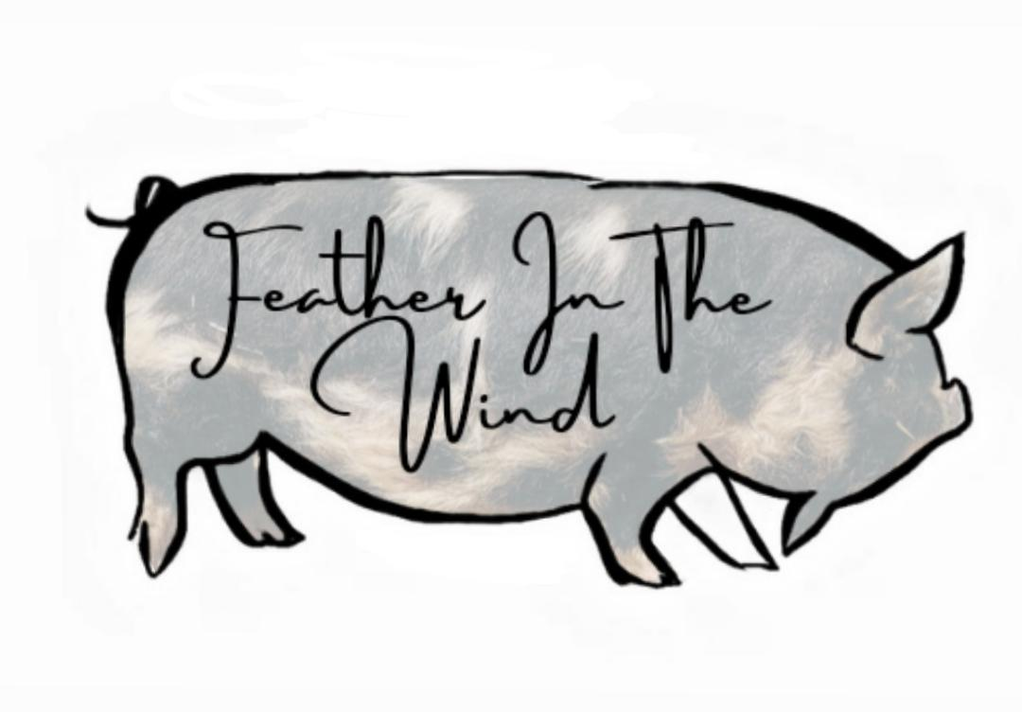

FEATHER IN THE WIND SALES CONTRACT

Date Sold:

**Seller: Buyer:**

Name: Kaleb & Brianna Keith Name:

Address: 5895 rd 14 Address:

City: Goodland State: Ks Zip: 67735 City: State: Zip:

|  |  |  |  |  |  |
| --- | --- | --- | --- | --- | --- |
| HerdBook # | Animal  Name | AKA | Sex | Date of Birth | Color |
|  |  |  |  |  |  |
|  |  |  |  |  |  |

THIS AGREEMENT is made on ,

by and between , hereafter referred to as BUYER, and Brianna Keith or Kaleb Keith of Feather in the Wind Kunekunes, hereafter referred to as SELLER/ FEATHER IN THE WIND KUNEKUNES.

Buyer agrees to purchase animal(s) below:

Buyer agrees to pick up Kunekune pig(s) on .

Upon payment in full and pick up/ transportation, SELLER agrees to promptly provide all necessary information for IKHR/AKKPS registration and transfer of ownership to BUYER. It is the SELLER’S responsibility to initiate the registration transfer. If the BUYER wishes to dual register the pig(s), it is the BUYER’S responsibility.

1. SELLER warrants they have clear title to the above Kunekune pig(s).
2. SELLER has the right to retain any Kunekune pig(s) of their choosing.
3. SELLER makes no other warranties, expressed or implied, including the warranties of health, fitness, height, growth rate, show quality.
4. BUYER had the option to review the condition and health of the animal on recorded videos and in person.
5. BUYER had the option for Veterinary Inspection at the BUYER’S expense- required to cross state lines.
6. SELLER does not offer any health or wellness guarantees after the Kunekune pig(s) have left Feather in the Wind Kunekunes due to the SELLER being unable to control the management and care of said Kunekune pig(s) once the pig(s) leaves our farm.
   1. See Breeding Health Guarantee Below
7. BUYER is responsible for all transportation fees including, but not limited to, veterinarian visit, CVI, crate/ trailer, mileage.
8. All registered Kunekune pigs will have DNA hair samples pulled and sent to UC Davis for parentage verification. SELLER will provide a copy of DNA report to BUYER upon request for pigs with the FITW prefix only.
9. All registered Kunekune pigs will be ear tagged or Microchipped prior to leaving Feather in the Wind Kunekunes. No exceptions.
10. SELLER will transfer/ register purchased Kunekune pigs through AKKPS/IKHR to the BUYER’s name. This transfer will be completed online, and the BUYER will receive pedigree and registration information directly from the registry in the BUYER’s email. If the BUYER wishes to dual register the pig(s), it is the BUYER’S responsibility.
11. BUYER will pick up Kunekune pig(s) on a prearranged date listed on the sales contract. Kunekune piglet(s) will not leave until a minimum of 8-10 weeks of age.
12. BUYER agrees to first right of sale – meaning if buyer later decides to sell a pig with the FITW prefix, they will contact and offer said pig(s) to Feather In The Wind Kunekunes first before offering elsewhere.

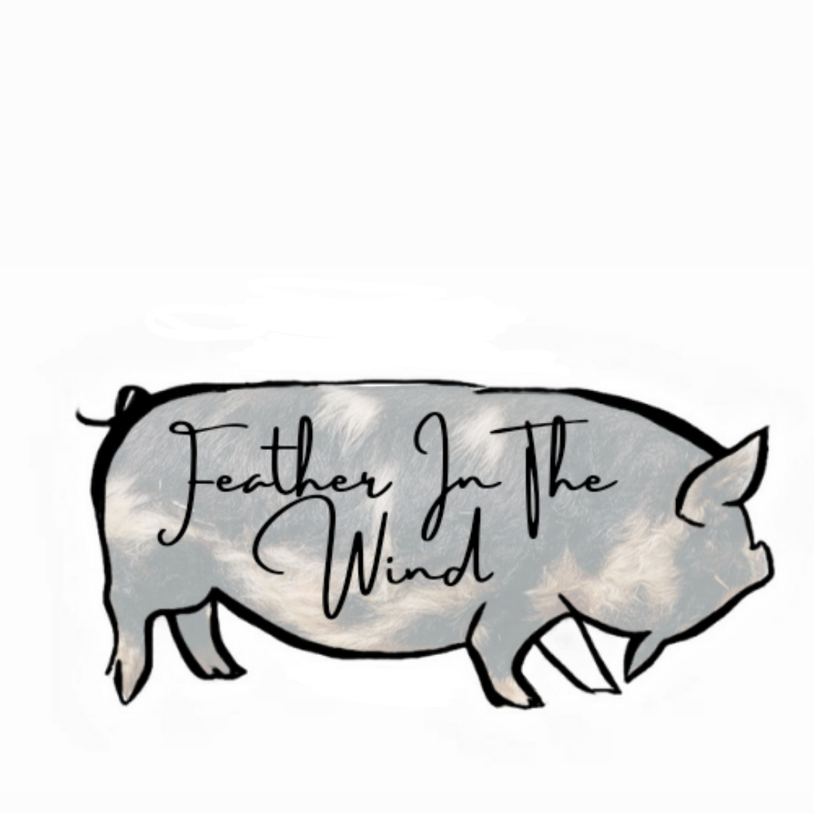

BREEDING HEALTH GUARANTEE

1. All stock sold is healthy with no joint swelling or lameness, no nasal discharge, no digestive concerns, and with reproductive organs intact.
2. Purchased Feather in the Wind Kunekune (FITW prefix) stock is covered under a 12-month health guarantee on genetic defects from the above Kunekune pig’s DATE OF BIRTH.
   1. If the BUYER suspects a genetic defect of the FITW pig listed above, the BUYER must provide a signed certificate from a veterinarian, including the pig’s ear tag number, confirming the GENETIC defect.
   2. If the BUYER suspects a genetic defect resulting in the death of the FITW pig listed above, the BUYER must provide a signed certificate from a veterinarian, including the pig’s ear tag number, confirming the GENETIC defect and cause of death.
   3. Should above pig(s) die and is questionable to the BUYER, it is the responsibility of the BUYER to hire a veterinarian to perform a necropsy (potentially including a histology from an accredited veterinary laboratory) to determine cause of death.
   4. Test Results must be provided to the SELLER.
   5. The SELLER has the right to provide necropsy reports to the SELLER’s swine veterinarian for his/her second opinion and diagnosis.
   6. Once the signed veterinarian certificate (including the pig’s ear tag number) is received by the SELLER, the SELLER will provide a replacement pig. The replacement choice will be at the SELLER’s sole discretion.
   7. Replacement pig’s hauling or shipping cost will be the sole responsibility of the BUYER.
   8. There is NO genetic health guarantee on any Kunekune stock sold NOT bred by Feather In the Wind Kunekunes (non FITW registered pigs).
3. SELLER is not responsible for any cost associated with this health guarantee including, but not limited to, veterinary fees, necropsy and lab fees, and transportation.
4. All intact stock sold as registered breeding stock comes with a Breeding Guarantee that the Fitw Kunekune pig(s) will breed or be bred by 24 months. The BUYER must be in contact with the SELLER if they have concerns with the pigs not breeding after 18 months.
   1. Breeding gilts and boars must be bred by the time they are 24 months of age. If all avenues have been addressed, including separating the pigs preferred to be bred and relocating them, and breeding is still not taking place, BUYER must provide a veterinarian certificate, including the pig’s ear tag number, confirming a breeding issue.
   2. Once the veterinarian certificate is received by the SELLER, the SELLER will provide a replacement pig. The replacement choice will be at the SELLER’s sole discretion.
   3. Replacement pig’s hauling or shipping cost will be the sole responsibility of the BUYER.
   4. The non-breeding pig must be returned to the SELLER. The non-breeding pig’s hauling or shipping cost will be the responsibility of the SELLER. Should SELLER choose not to have the pig returned, SELLER and BUYER will contact IKHR or AKKPS to have the pig culled from the herd book and registration pulled.
   5. SELLER is not responsible for any veterinarian fees or lab tests associated with this Breeding Guarantee.

**Conditions**

1. Breeding guarantee is null and void if intact gilts and intact boars are housed together after 4 months of age prior to breeding age, 12-24 months.
2. Breeding guarantee is null and void if SELLER and BUYER are not in direct contact with each other regarding the pig’s breeding history.
3. Breeding guarantee is null and void if the BUYER uses any off-label medications, including off label medications prescribed by a veterinarian.
4. Health and Breeding Guarantee is ONLY for Feather in the Wind (FITW) pigs. This health and breeding guarantee is not applicable for pigs sold through Feather in The Wind Kunekunes, but not registered FITW or born on the property of Feather in The Wind Kunekunes.

**This Health and Breeding Guarantee is non-negotiable.**

Signature of Seller: Brianna Keith Date: BUYER’S signature indicates full agreement with the terms and conditions of this contact.

SELLER’S Signature: Brianna Keith Date:

Kaleb & Brianna Keith, Feather in The Wind Kunekunes

Email: featherinthewind.dairygoats@gmail.com

Phone: 785-821-3289

BUYER’S Signature : Date:

BUYER’S Name :

BUYER’S Email :

BUYER’S Phone :