2022 Oriental Holistic Massage & ACT Sport Massage
Female Massage Health & Concern Form

Please note: The information on this form is kept strictly confidential.

First Name: ……………………………………………Surname: ………………………………………
Postcode: ……………………….
Date of Birth: ……………………. Contact Number: ……………………………………….
Emergency only contact name and number: ………………………………………………………
Occupation: ………………………………………………………………
Email address: (Please Print) ……………………………………….
Reason for visit?......................................................................
Where did you find Oriental Holistic Massage or ACT Sports Massage?....................................................

Have you had, or are you currently suffering from, any of the following? Please tick the one you have.

Varicose veins |  | Kidney Ailments | Blood Clots | Infectious conditions
Headaches |  | Heart Ailments | Stroke | Aids / HIV
Depression |  | Heart pacemaker | Numbness or Pins & Needles anywhere | Herpes
Neck/spinal injury |  | Joint replacement | Allergies | Shingles
Neck or spinal surgery |  | Diabetes | Hepatitis A, B, C | Skin Disorders
High/low Blood Pressure |  | Epilepsy | Cold/flu/fever | Osteoporosis (Bones)
Have you or did you have breast cancer? Yes-No  L or R |  | Mastectomy R-L or both? Yes-No | Do you have breast implants Yes - No | Do you have sore breasts? Yes-No
Fibromyalgia |  | Arthritis? If so, where? | Please mark areas of pain (P) or injury (INY) or No massage (NM) on the chart below.  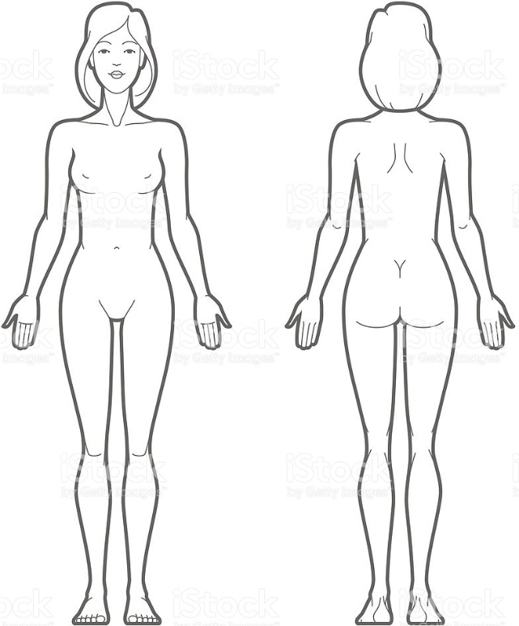
Are you pregnant?

Any other conditions that are not listed above?

Are you currently under any medical or health care treatment, taking medication, or have you had recent surgery? If so, please describe……………………………………………………………………………………
………………………………………………………………………………………………………………….....
................................................................................................................................................................

Client Signature………………………………… Date………………
Massage Therapist Sign .................................. Date: ....................

