SITE READINESS GUIDELINES

(C) PAR Technology Inc. (2019). All rights reserved

**Site Readiness Requirements**

Robin_Mast@partech.com

www.partech.com

2019

# Site Readiness Requirements

To ensure a smooth and seamless PAR/Brink installation, your location must be properly prepared. This document outlines the preparations that must be made to your site prior to the implementation of your system. This information is important if you’re opening a new restaurant, looking to add to or change the configuration of your existing restaurant, or have a space that requires multiple access points or specific access point positioning. When your Site Survey is scheduled all of what is on this document will be checked & Tested. You will know what needs to be completed on this list after your initial Site Survey results.

***Note*:** PAR/Brink does not provide mounting or cabling services and that cost is not included in your implementation quote. Your PAR/Brink Project Manager can, however, consult with the technician following the site survey on cabling placement and requirements.

**For a glossary of terms and phrases, see page 8.**

# Construction:

## We never recommend installing the PAR/Brink hardware while there is, or will be, active construction.

Here are common problems we find with systems installed before or during construction:

* Dust from the construction gets into the terminals/handhelds and breaks them. Hardware broken by dust **will not be replaced.**
* During construction, other onsite contractors often interfere with the PAR/Brink network. Whether it’s a contractor working on the security system or simply unplugging a network device to charge their cellphone, these interferences can lead to major troubleshooting and unnecessary costs to you.
* As a result of these problems, installing PAR/Brink before the site is ready usually leads to overages on the implementation price quote.

# Ladders / Ceilings:

Our implementation engineers do not travel with ladders. We require that customers provide ladders or stepstools if they are necessary. Common installation activities that require ladders or stepstools are:

* Access Point Installation (always recommended on ceilings)
* KDS Installation
* Network Installation

If you need access points installed and have ceilings higher than 10ft, please request that your access point(s) get delivered early so that the electrician who runs cables for the access point can install the devices at the same time.

# Internet:

The internet requirements for the PAR/Brink installation are as follows:

* A broadband internet account must be established prior to the PAR/Brink installation. Proper internet connectivity equipment must be purchased and installed ahead of time.
* We require **1 free port in the ISP MODEM** **(Please refer to the below Picture Diagram)**
* Cabling must be run from your internet connection point to the different terminals, printers, KDS and access points. Remember, we don’t offer cabling services but would be happy to advise your technician on requirements.
* PAR/Brink recommends network speeds of **15 MBPS for download and 5 MBPS for upload**. This will ensure that your system has enough bandwidth to support the POS needs in addition to video surveillance, music streaming, or other guest network services that are not managed by PAR/Brink.
* If your internet comes up as a static IP scheme during your site survey results with the technician it is very important that PAR/Brink have this information, it will be needed to configure properly the Cradle Point Firewall/Router. If you do not know this information your ISP provider can give it to you.

**NOTE: If you currently have a 4 port ISP Modem and all 4 ports are in use for your current store Network we will need you to free up 1 of those PORTS for PAR/Brink use: It is very IMPORTANT that the POS Network be separated from your store Network. Example below does not have to be port 4 specific just a free port 1-4 whichever is available to free up.**

**PAR/ BRINK ISP NETWORK**

**PORT:**

# 

# Local Area Network:

Prior to system installation, your site must be cabled properly to support the PAR/Brink terminals, printers and access points. The following PAR/Brink hardware only support wired Ethernet connections:

* Terminals
* KDS
* Kitchen Printers
* Access Points

The only PAR/Brink devices that support wireless connectivity are the handheld tablets.

PAR/Brink requires that all Ethernet cables be rated at 100MBs or higher. You can run the PAR/Brink devices on Ethernet cables rated between 10MBs and 100MBs, although it is **NOT** recommended. Cables rated between 10MBs and 100MBs often lead to system inconsistencies. Any cable rated below 10MBs should not be used. If PAR/Brink implementation engineers are performing the site survey and or installation, they will not install a device on a cable rated below 10MBs.

**The network cabling requirements for the PAR/Brink installation are as follows:**

## Terminal & Terminal Bundle Cabling Requirements:

* A minimum of one, ideally two, Cat 5e or Cat 6 cables must be run from the desired location of each terminal to the location of the Internet modem. Terminal cable drops need to be terminated with a RJ45 FEMALE jack to the T568B wiring scheme, ideally into a wall plate or a surface mount box. Six to ten feet of slack should be left on each end of each cable to accommodate last minute adjustments. Each cable must be labeled with a matching identifier on each end. Use a different identifier on each cable to facilitate troubleshooting.

If you only run one cable to the terminal, a switch must be used to provide network connectivity to the Credit Card Device.

Figure 1.1 shows an example of a wall plate containing two RJ45 jacks.

## Access Point & Kitchen / Server Printer Cabling Requirements:

* A single Cat 5e or Cat 6 cable must be run from the desired location of each access point and kitchen/server printer to the location of the Internet modem or DEMARC. Access Point and printer cable drops must be terminated with a RJ45 FEMALE jack to the T568B wiring scheme, ideally into a wall plate or surface mount box. At least 10 feet of slack should be left on each end of each cable to accommodate last minute adjustments. Each cable must be labeled with a matching identifier on each end. Use a different identifier on each cable to facilitate troubleshooting.
* Figure 1.2 shows an example of a wall plate containing one RJ45 jack.

**Figure 1.1**

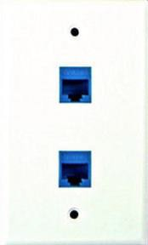

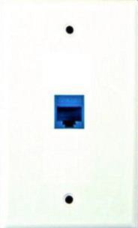**Figure 1.2**

## Home Run Cabling Requirements:

* The home runs next to the Internet modem or DEMARC need to be terminated to a patch panel (Figure 2.1). If only a few cables are being run, they can be terminated to a wall mounted plate (Figure 2.2).

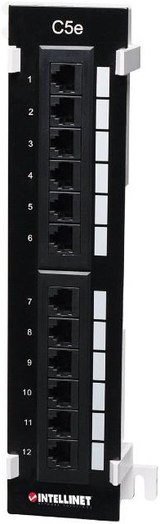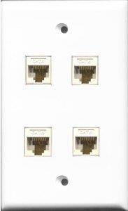**Figure 2.1 – A Patch Panel** **Figure 2.2 – A Wall-Mounted Plate**

## Cabling Organization:

When your implementation engineer installs PAR/Brink, they will isolate the PAR/Brink hardware as much as possible. PAR/Brink is only responsible for the PAR/Brink devices and will attempt to organize the cabling for the PAR/Brink network.

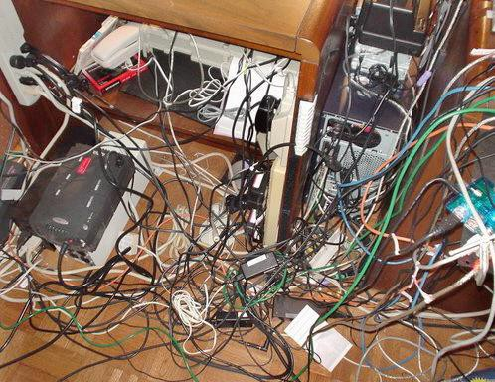If your existing network is unorganized (see image to the left), it can lead to several challenges:

* 1. Installation overages in addition to your initial implementation quote
  2. Difficult troubleshooting with PAR/Brink Support and other service providers
  3. Communication problems leading to system instability especially in a cloud environment.

If your network is unorganized and you’d like to clean it up, PAR/Brink can recommend contractors to provide that service.

# Wireless Network:

Some customers use their existing wireless infrastructure to run the PAR/Brink system, **however we do not recommend this.** Should you choose this option, these are the requirements to successfully install your system:

* A secure VLAN must be provided for the PAR/Brink network. Ideally Quality of Service (QoS) will be setup to ensure enough bandwidth is dedicated for PAR/Brink. PAR/Brink recommends network speeds of **15 MBPS for download and 5 MBPS for upload.**
* PAR/Brink requires wireless signal quality between 55-67dBm **in all areas of the restaurant where you require wireless connectivity with the PAR/Brink handheld tablets.** Wireless networks with less than 67dBm may experience handheld syncing issues, which can then lead to delayed kitchen tickets, re-appearing checks and overall system instability.

* BEST PRACTICE – All wireless access points should be placed on the ceiling in unobstructed central locations to ensure acceptable signal quality.

# Electrical & Power:

The electrical requirements for the PAR/Brink installation are as follows:

* There must be two standard receptacles within six feet of each terminal or terminal bundle.
* There must be a standard receptacle within six feet of each printer.
* Access Points do not need a receptacle. If no receptacle is accessible to the access point, then you must use a Power-Over-Ethernet (POE) injector or POE-enabled switch to provide power for the device(s).
* An isolated ground circuit is highly recommended.
* No refrigeration, blending or heating devices should be plugged into same outlets or on the same circuit as the PAR/Brink terminals.

**UPS:**

* We recommend that the PAR/Brink provided hardware be on a UPS
* Better customer experience - fewer failures and will act as backup for a bit if power outage occurs
* Better for Customer & PAR - fewer break/fix

**While PAR/Brink does not require dedicated isolated ground circuits we HIGHLY RECOMMEND it is always a best practice to avoid plugging Terminals into any outlet with appliances. Motorized devices cause power fluctuations, which will negatively impact the PAR/Brink Terminals, printers leading to hardware instability.**

# Counter Tops:

If terminals or terminal bundles will be placed on counters or bars, especially on surfaces visible to your customers, then 2-2.25-inch holes must be cut into the surfaces to allow the cables to run underneath. PAR/Brink does not cut these holes. A hole must be located within 2 feet of the location of each terminal. Keep in mind that terminals generally rest directly on top of cash drawers which are 16”x16”. Holes must be cut such that the cash drawer does not cover them.

# Wall Mounting:

We require that all wall mounts be installed prior to your PAR/Brink installation. If you have wall-mounted devices (kitchen display screens) and have questions prior to installation, please ask your project manager.

# Help?

If you have questions about networking requirements for PAR/Brink, work with your project manager.

**The below example Network diagram is a best practice POS Isolated Network configuration:**

**The below terminal’s, KDS, Kitchen Printer, Credit card terminal’s and the Wi Fi Access point all are home run to the patch panel & then uplinked to the network switch:**

**15 MBPS Download &**

**5MBPS Upload Speeds**

**INTERNET: ISP MODEM:** **CRADLE POINT FIREWALL ROUTER:**



**NETWORK SWITCH:**

**PATCH PANEL:**

**Serial RP**

**T1**

**Serial RP**

**T2**

**KPP**

**KDS 1**

**KDS 2**



**HH3**

**HH1**

**HH2**

**POS Isolated SSID for Tablet’s**

**Wi Fi Access Point**

**CC T2**

**CC T1**

# Site Readiness Checklist

|  |
| --- |
| The restaurant is NOT in active construction. All heavy construction is  complete and no addition construction will be necessary which could compromise the hardware being installed or cause it to be moved. The most common construction that causes problems are with floors, bars and counters. It’s essential that these are complete before the PAR/Brink system is installed to avoid implementation overages. |
| Internet service is turned on with speeds at least 15 megabytes for download and 5 megabytes for upload. |
| Power is available within 6 ft to each place where a terminal, KDS, printer and access point will be located. If no power is available for the access point(s) then please ensure you have a power-over-Ethernet (PoE) enabled switch or device. |
| Network cabling is **run and terminated** to each place where a terminal, KDS, printer and access point will be located. |
| All network cabling is homerun back to the Internet modem or DEMARC. |
| The bar(s) / counter(s) are finished, and holes are cut to accommodate the  terminals’ cabling. |
| Wall mounts are installed. |
| Ladder is present capable of reaching the ceiling (if applicable). |

**Appendix / Glossary**

|  |  |
| --- | --- |
| Term | Definition |
| **Broadband Internet** | Broadband Internet refers to the high-speed internet connection you pay for from your cable/telephone provider. |
| **Cat 5e/6 Ethernet Cables** | Cat 5e Ethernet cables refer to the network cabling that connects the PAR/Brink devices.   * Cat 5e has been around for over 15 years. Cat 5e cables are typically 24 gauge twisted pair wires, which can produce a Gigibit network at distances up to 328 ft. * Cat 6 cables came out a few years after Cat 5e. This cable gave the ability to have a 10 Gigabit network. The 10 Gigabit network on Cat 6 cables is limited to 164 ft. After that distance its ultimate speed is 1 Gigabit. |
| **Terminating Cables** | Terminating cables generally refers to ensuring the Ethernet cables in your walls are attached to wall plates with female connections. PAR/Brink requires RJ45 connections using T568B wiring scheme. |
| **Switch** | A Switch is a computer networking device that connects devices together on a computer network. It uses packet switching to receive, process and forward data to the destination device. |
| **Access Point** | In a wireless local area network, an access point is a station that transmits and receives data. Each access point can serve multiple users within a defined network area; as people move beyond the range of one access point, they are automatically handed over to the next one. |
| **Cable Drop** | A connection point in a network. Network drops are typically wall outlets with an Ethernet jack that a computer or other network device can plug into. |
| **Internet Modem vs. Router** | The two major components in a small computer network are a modem (cable or DSL) and a wireless router. The router is wired to the modem, and the modem is wired to the cable company's coaxial cable or the telephone company's DSL phone line.  The modem establishes and maintains the connection with the Internet provider's service and converts the signals from and to the router appropriately. The router forwards traffic destined for the Internet to the modem, while keeping internal traffic (computer to computer, computer to printer, etc.) from leaving the network. |

|  |  |
| --- | --- |
|  | Cable Modems typically provide some routing capabilities, but the PAR/Brink system requires a separate routing device. |
| **VLAN** | A VLAN is a group of devices on one or more LANs that are configured to communicate as if they were attached to the same wire, when in fact they are located on several different LAN segments. Because VLANs are based on logical instead of physical connections, they are extremely flexible.  VLANs are typically used with larger networks where traffic needs to be segmented. |
| **dBm** | dBm (sometimes dBmW or decibel-milliwatts) is an abbreviation for the power ratio in decibels (dB) of the measured power referenced to one milliwatt (mW). It is used in radio, microwave and fiber optic networks as a convenient measure of absolute power because of its capability to express both very large and very small values in a short form. |

|  |  |
| --- | --- |
| **A close up of a device  Description automatically generated Isolated Dedicated Circuit** | The primary reason for the use of isolated grounds (IG) is to provide a noise-free ground return, separate from the equipment grounding (EG) return. The EG circuit includes all of the metal conduit, outlet boxes, and metal enclosures that contain the wiring and must be grounded to provide a safe return path in case of fault currents. The IG provides an insulated, separate ground path for the ground reference in electronic equipment, such as computers, hospital equipment, and audio equipment. IG does not break [ground loops](https://en.wikipedia.org/wiki/Ground_loop_(electricity)), which can damage equipment like computers, printers, etc.. Interconnected computer equipment often benefits from single-point grounding. |

