[](https://www.helicopterspecs.com/)

• • [**HOME**](https://www.helicopterspecs.com/)

* [**HELICOPTER TYPES**](NULL)
  + [**UTILITY**](https://www.helicopterspecs.com/search/label/Utility%20Helicopter)
  + [**MILITARY**](https://www.helicopterspecs.com/search/label/Military%20Helicopter)
  + [**UNMANNED**](https://www.helicopterspecs.com/search/label/Unmanned%20Helicopter)
* [**AGUSTAWESTLAND**](https://www.helicopterspecs.com/search/label/AgustaWestland)
* [**AIRBUS**](https://www.helicopterspecs.com/search/label/Airbus)
* [**BELL**](https://www.helicopterspecs.com/search/label/Bell)
* [**BOEING**](https://www.helicopterspecs.com/search/label/Boeing)
* [**MD HELICOPTERS**](https://www.helicopterspecs.com/search/label/MD%20Helicopters)
* [**RUSSIAN**](https://www.helicopterspecs.com/search/label/Russian)
* [**ROBINSON**](https://www.helicopterspecs.com/search/label/Robinson)
* [**SIKORSKY**](https://www.helicopterspecs.com/search/label/Sikorsky)



[Home](https://www.helicopterspecs.com/?&max-results=7) / [Bell](https://www.helicopterspecs.com/search/label/Bell?&max-results=7) / [Utility Helicopter](https://www.helicopterspecs.com/search/label/Utility%20Helicopter?&max-results=7) / Bell 407GXi Specs, Interior, and Price

**Bell 407GXi Specs, Interior, and Price**

[Admin](https://www.helicopterspecs.com/2019/07/bell-407gxi.html)  [3 years ago](https://www.helicopterspecs.com/2019/07/bell-407gxi.html)  [Bell](https://www.helicopterspecs.com/search/label/Bell?&max-results=7), [Utility Helicopter](https://www.helicopterspecs.com/search/label/Utility%20Helicopter?&max-results=7)

**[Bell 407GXi Specs, Interior, and Price](https://www.helicopterspecs.com/2019/07/bell-407gxi.html" \t "_blank)** – Bell 407GXi is a multi-role helicopter developed and manufactured by Bell (formerly Bell Helicopter), a subsidiary of Textron. This helicopter was developed as an upgraded version of the Bell 407GXP helicopter, expected to replace its predecessor.  
  
Bell 407GXi was launched by Bell at Heli-Expo 2018 in February 2018. This is the first helicopter launched by the company after rebranding as Bell. The helicopter received certification from Transport Canada in January 2018.

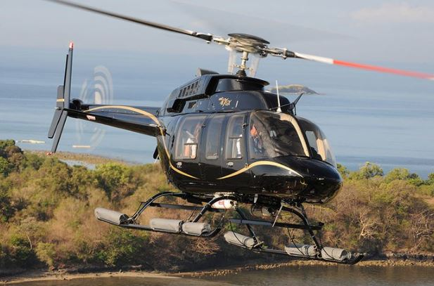

**Bell 407GXi Specs**

The Bell 407GXi is a modern version of Bell 407GXP, combining new interior design with enhanced payload capacity, without reducing quality.  
  
The helicopter's front plane is an aluminum honeycomb and carbon graphite structure, while the cabin is a semi-monocoque structure made of carbon fiber composites. The helicopter tail boom integrates horizontal stabilizers and vertical fins, rotor hubs and blades.  
  
The main rotor, mounted to a flexible beam hub, has four fiberglass blades, while a semi-rigid tail rotor is equipped with two blades. The landing gear is a type of tubular slippage with slip shoes that can be replaced.  
  
The helicopter has an empty weight of 1,224kg and can carry up to 2,772kg of external loads. It has the capacity to carry a useful load maximum of 1,043kg.  
  
The modular design of helicopters allows it to carry out corporate (HEMS), corporate, energy, public, and helicopter emergency medical services.

**Bell 407GXi Engine**

Bell 407GXi helicopter is powered by a Rolls-Royce 250-C47E / 4 engine. The turboshaft engine is equipped with a digital electronic electronic control system (FADEC) with full digital authority. This develops a maximum takeoff power of 643kW (862shp). The main tank and additions on the helicopter can carry around 555l of fuel.  
  
The helicopter's maximum cruising speed is 246 km / hr, while the maximum range is 624 km. The helicopter has a maximum durability of four hours.

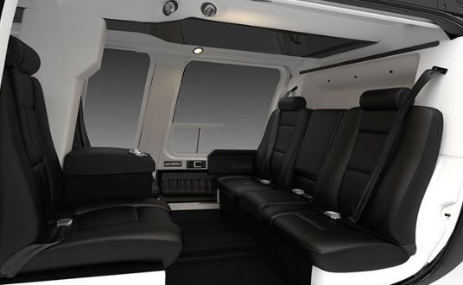

**Bell 407GXi Interior**

The Bell 407GXi helicopter has a spacious 2.4 m³ cabin, which offers seating for pilots and six passengers in a standard configuration. The cabin configuration can be changed as needed and the seats can be adjusted in gray, black, blue and two-tone skin tones.  
  
The ergonomic cab design allows maximum sunlight to enter the cabin and improves view and visibility for passengers. The helicopter is further equipped with soundproof technology to reduce noise levels in the cabin.  
  
Modular cabs can be installed with mission-specific equipment such as the bi-fold 155cm door to facilitate patient loading and unloading. The ability to operate in extreme weather conditions at high altitudes to provide enhanced supervision makes it best suited for public mission.

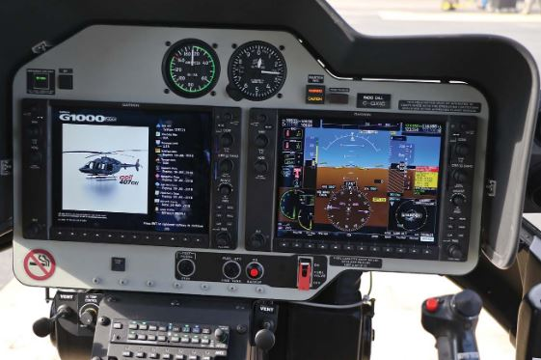

**Bell 407GXi Cockpit and Avionics**

The Bell 407GXi helicopter is equipped with Garmin G1000H integrated avionics, which features 10.4in high definition LCD screens and primary flight display (PFD). It features sophisticated processing equipment, which provides information needed to improve situational awareness, while alleviating the workload of pilots.  
  
The hyperspectral imaging system (HSI) technology above the cockpit offers maps and intelligent insight to pilots.  
  
The next flight deck incorporates a traffic information system (TIS), a helicopter field warning system (HTAWS), a tail rotor camera display, and Garmin helicopter synthetic (HSVT) vision technology.  
  
The on-board power situation indicator (PSI) provides precise information about power settings. The intercom system is integrated with a pointing machine and crew warning system (EICAS), which provides audio alerts during emergencies.  
  
The Bell 407GXi on-board navigation system includes high frequency communication transceivers (VHF COM), GPS / WAAS receiver glideslope receivers, and GTX 335R Extended Squitter (ES) S Mode transponders.

**Bell 407GXi Price**

The price of the latest Bell 407GXi is US $ 3.1 Million. Delivery of the Bell 407GXi helicopter is scheduled to begin in second quarter 2018.  
  
More information about Bell 407GXi helicopter specifications and price can be seen on the official website [www.bellflight.com](http://www.bellflight.com/).