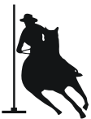
Friday/Saturday Night Lights!
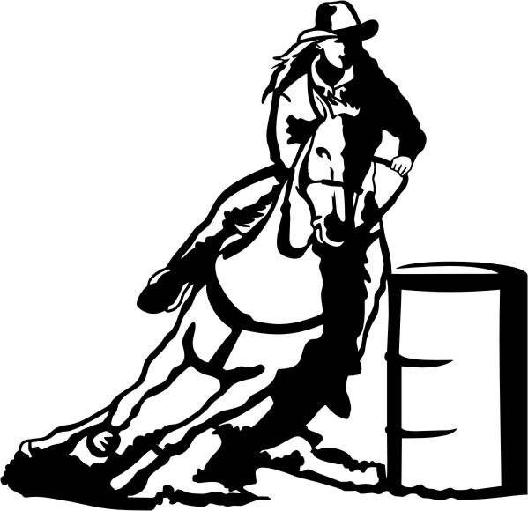
Morrison County Fairgrounds, Little Falls MN, 56345
Directions: HWY 27 East of Little Falls, Left (North) onto County Rd
43 (Hawthorn Road) and then watch for gravel and sign on left

Food and Bathrooms on site!

Friday and Saturday August 9th and 10th
⁻ 5:00pm to 6:30pm exhibitions Average awards for the
⁻ 6:30pm to 6:45pm open arena Weekend!! Both opens count
followed by big drag Both days towards average
⁻ 7:00pm Start Awards!!
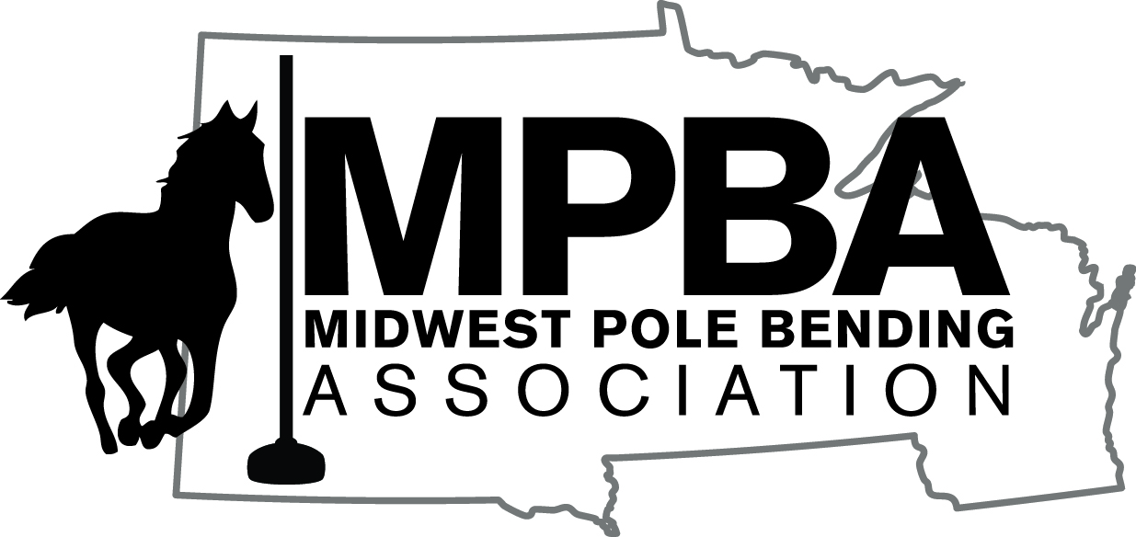
Events:
- Peewee barrels (10 and under) $5 entry fee
- 1st Youth 4D ½ sec split Barrels (UBRA/PEWC) $10 entry fee
- 1st Open 4D ½ sec split Barrels (UBRA/PWEC) $15 entry fee
- 2nd Youth 4D ½ sec split Barrels (UBRA/PEWC) $10 entry fee (carry overs allowed)
- 2nd Open 4D ½ sec split Barrels (UBRA/PWEC) $10 entry fee (carry overs allowed)
- Futurity and Derby Sidepots (off of 1st Open only) $10 entry fee
- Pole Bending, 3D, 1 second split $10 entry fee
- $10 office fee and Exhibitions are $4 each or 3 for $10

- For more information contact Stephanie at (320) 630-6887. Overnight camping available upon contacting a head of time ($25).
- Carry overs go from 1st youth to 2nd youth and 1st open to 2nd open

***No Refunds
***All opens (1st and 2nd opens both Friday and Saturday) count towards cash average awards and must be present to claim!
Not Responsible for Accidents, Riders and or Horses

