Friendship A.M.E. Church
2024 Spring Festival
Vendor’s Rules & Regulations

- Setup time will begin at 9 a.m. and must be completed by the Spring festival opening at 11 a.m.
- The Organizer will be provided a 12’ X 12’ space. You must provide your own canopy tent, table & chairs.
- No alcoholic beverages are allowed or sold on the premises.
- No electricity/water available- you must bring your generator and water supply.
- Organizers will not be held responsible for accidents, theft, or mishaps.
- Props, trailers, tents, and any other equipment may not exceed the boundary of the contestant’s assigned space. No tent stakes can be driven into the asphalt.
- Hand sanitizer stations will be located throughout the vendor areas.
- Trash cans will be located throughout the venue, with trash monitored and disposed of into on-site dumpsters provided more regularly to ensure bins do not exceed capacity.
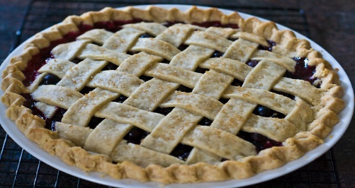
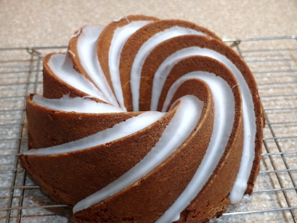
Friendship A.M.E. Church
Spring Festival
Baking Competition
Rules & Regulations
Baked Categories
All baked entries must fit one of the two category descriptions:
- Cake: This category is intended for baked cakes. Cakes may be single or multi-layer.
- Pie: This category is intended for baked pies (fruit, custard, cobblers, etc.).
Rules
- Each entry must be homemade.
- Please include a short anonymous description of each entry. (This description aims to better inform the judges of the entrant’s vision, process, materials, and technique, which may not be evident from viewing the finished product.)
Baking Competition Judging:
All entries must meet the requirements of the category entered. Entries will be judged according to the following criteria:
- Presentation (1 to 10 points)
- Taste (1 to 10 points)
- Texture (1 to 10 points)
- Creativity (1 to 10 points)
A maximum total of 40 points is possible

Prizes for Cake
1st place $100 gift card
2nd place $75 gift card
3rd place $50 gift card
Pie Categories
1st place $100 gift card
2nd place $75 gift card
3rd place $75 gift card

I/we acknowledge that we have read and agree to follow the protocol requirements as presented.
Name: _________________________________ Signature: _____________________________

Date: _________________________________

