**15th Annual Willmar Youth in Harmony Festival**

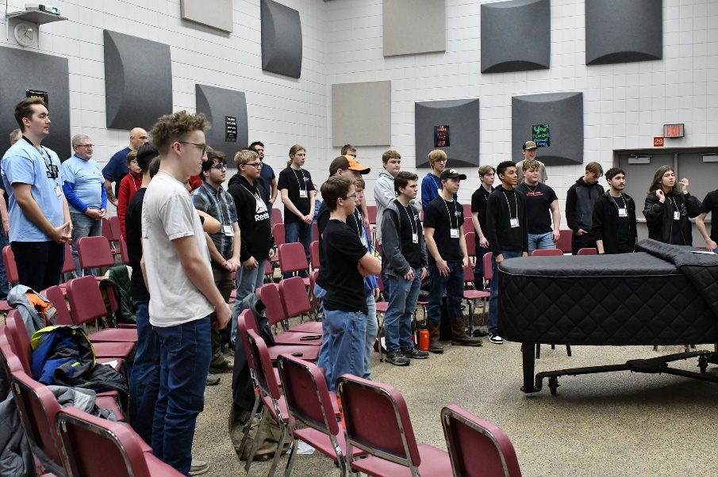The 15th Annual Willmar Youth in Harmony Festival, hosted by the West Central Connection Chorus, was a resounding success, bringing together young voices and seasoned barbershoppers for an unforgettable day of harmony. Held on February 1, 2025, at Willmar Senior High School, this cherished event introduced 32 high school students to the joy of a cappella singing and the rich traditions of barbershop harmony.

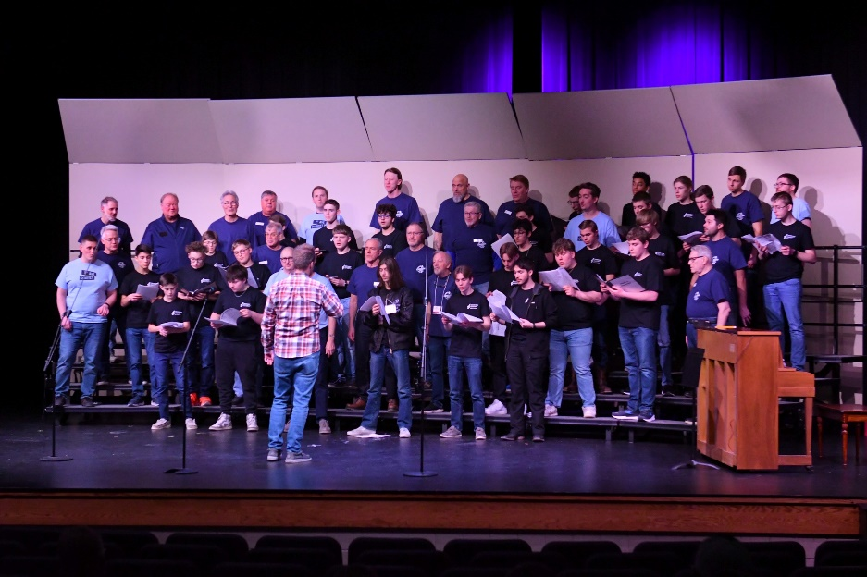The day was packed with music, learning, and camaraderie, culminating in a free public concert that brought the house down. Over 50 voices filled the stage, including performances by the Youth in Harmony Chorus, directed by Pete Benson, and featured sets from the talented teaching quartets—First Ave. Quartet and Sound Image Quartet. Their vibrant performances showcased the power of harmony and left a lasting impression on both singers and audience members.

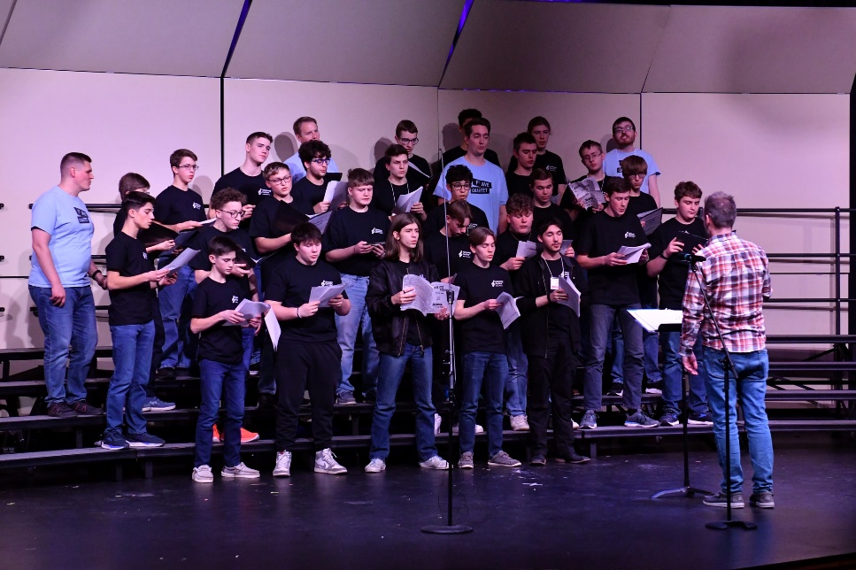A huge thanks goes to the Land O' Lakes (LOL) Next Gen Barbershop Committee for their generous grant, which helped fund the teaching quartets. This vital support allowed students to learn directly from experienced barbershoppers, gaining insights that will inspire their musical journeys for years to come.

For the West Central Connection Chorus, this festival is more than just an event—it’s a tradition and a mission. With over 500 young men having participated since its inception, the Youth in Harmony Festival continues to be a cornerstone of their outreach. As Jeff Danielson from the chorus proudly shared, *“We take great pride in offering young men this opportunity to experience the joy of singing and bringing happiness to others. We are grateful to LOL for their support and look forward to continuing this legacy.”*

The excitement doesn’t end here! Plans are already underway for next year’s festival, and the West Central Connection Chorus invites interested students and educators to join in the fun. For more information or to get involved, contact them at **westcentralconnectionchorus@gmail.com**.

The future of barbershop harmony is bright, and events like the Willmar Youth in Harmony Festival ensure that the next generation will continue to ring those chords for years to come.