**Sirena Quartet’s Unforgettable Journey at Midwinter**

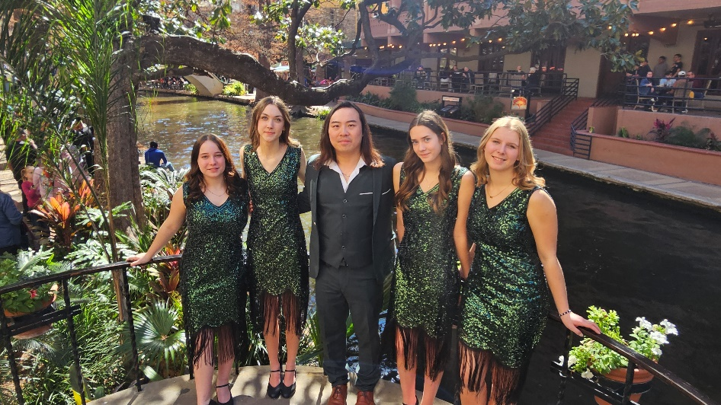As a mother, witnessing my daughter Seneca’s journey with the Sirena Quartet has been nothing short of incredible. I am beyond thrilled by the experiences she has gained through barbershop, and in conversations with other parents, it’s clear that we all share this joy. Barbershop brings a unique camaraderie unlike any other music program my daughter has experienced—it’s a true family built on harmony and heart.

Sirena Quartet had the honor of representing the Land O' Lakes District at the Barbershop Harmony Society's Midwinter Convention, competing in the Junior Varsity Quartet Competition. From 38 video submissions, Sirena earned their place among the top 15 quartets, and in January, they proudly placed 8th in a field brimming with talent.

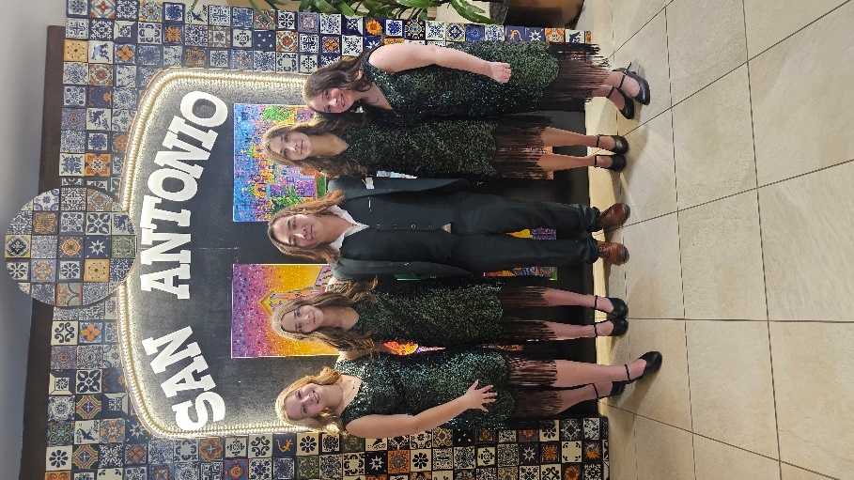Their achievement is remarkable, especially considering the challenges they overcame. Unlike many quartets that rehearse together at the same school, these young women come from four different schools across Saskatchewan. Emmie (tenor) attends Bedford Road Collegiate, Seneca (lead) goes to Warman High School, Brynn (baritone) attends Centennial Collegiate, and Oakley (bass) is a Grade 8 student at Lakeview Elementary. Despite their distance, they united through their shared passion for harmony.

The road to Midwinter had its obstacles. Just a month before the convention, they had to welcome Emmie as their new tenor due to unforeseen circumstances. Yet, through resilience and determination, the quartet came together and performed beautifully.

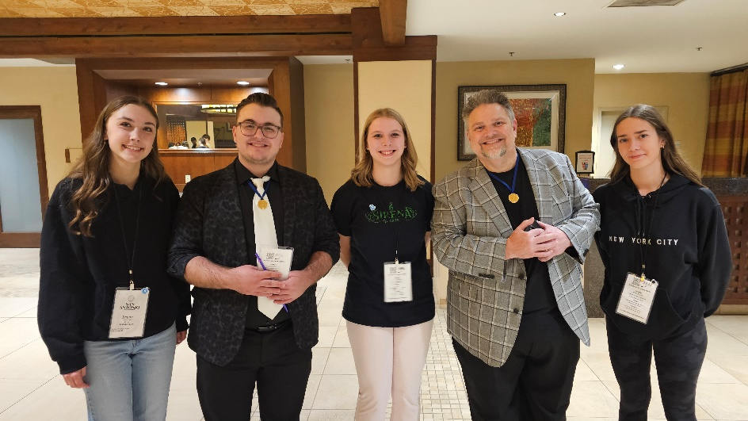As a parent, my gratitude to the Land O' Lakes District runs deep. From the invaluable coaching at the District Convention to the generous support that helped them reach Midwinter, we are profoundly thankful for the community that made this journey possible. A special thank-you goes to their lead quartet coach, Justin La, whose guidance has been instrumental in their success. Additionally, we are deeply grateful to their external coach and contest song arranger, Jake Bavarsky, for his expert coaching and artistry.

The competition, however, was only part of their joy. The most cherished memories were made during late-night tag singing with new friends and barbershop legends. Meeting and singing with icons like Tony DeRosa, Joseph DeRosa, and Tim Waurick left them inspired and filled with excitement for what lies ahead.

From a proud mother’s heart—thank you, Land O' Lakes District, for helping my daughter and her quartet find their voices, their community, and their passion for barbershop. The future of this art form shines bright, and I can't wait to see where their harmony leads them next.

Danielle Santo - Mother and Manager of Sirena Quartet

P.S. We would also like to share a little tag in thanks for all that you do!

Scan the QR Code with your phone or click the link below to watch the special video!  
<https://youtu.be/Md1lKId1JIM>