**Penny's Burlington High School Sets a New Standard at Midwinter**

Penny and her Burlington High School students made history at this year’s Midwinter Junior Varsity Chorus Festival by sending a record-breaking three choruses from a single school—a true testament to Penny’s passion and leadership. It’s no surprise she was honored as the NAFME Music Educator of the Year and the Land O' Lakes (LOL) Golden Chord Award Recipient in 2023!

The three ensembles—*Here Comes Treble* (SSAA), *The Reigning Men* (TTBB), and *Vocamotion* (SATB)—delighted audiences with beautifully selected repertoire that showcased their versatility and artistry. A special highlight this year was their collaboration with Jake Bavarsky, an esteemed arranger, Musicality Candidate Judge, and Music Director of the international qualifying chorus *Prism*. Together, they brought a fresh and playful twist to the beloved classic *Sesame Street's Rubber Duckie*, arranged by Bavarsky exclusively for Penny’s ensembles.

The excitement began on their first day, when all three choruses had the privilege of working with Jake in a coaching session that was as inspiring as it was educational. His expert guidance, combined with the enthusiasm of Penny’s students, was a shining reminder that the future of barbershop is bright.

The results spoke for themselves—*Here Comes Treble*, *The Reigning Men*, and *Vocamotion* all received outstanding ratings from the judges. It was a proud moment for Penny, her students, and the entire Land O' Lakes District.

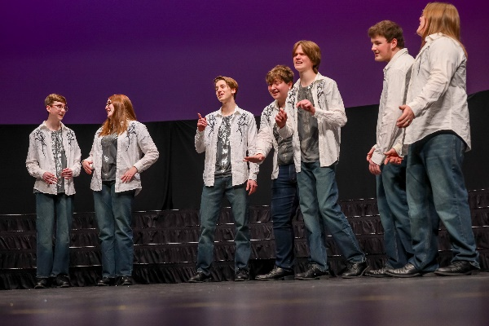This incredible achievement is a reflection of Penny’s passion, dedication, and belief in her students. Her work has not only elevated Burlington High School but has also brought honor to our entire district. We are so proud to celebrate Penny and these amazing young singers who represent the future of barbershop harmony.

**Looking Ahead:** If you know of any high school teachers who would love the opportunity to participate, next year’s Midwinter is in Pasadena, California. I’d be happy to get them plugged in and provide more information. They can reach out to me directly. justinla92@hotmail.com

– Justin La, Chairman, Next Generation Barbershop Committee