Celebrating Music Educators: Call for 2025 Golden Chord Award Nominations
Music educators are the heart and soul of our barbershop community, igniting a passion for harmony and shaping the next generation of singers. The Land O' Lakes District proudly recognizes these remarkable educators through the Golden Chord Award – Music Educator of the Year, honoring those who inspire, uplift, and empower their students through vocal music.
In 2023, we celebrated Penny for her extraordinary contributions—her record-setting three choruses at the Midwinter Junior Varsity Chorus Festival reflected her dedication and artistry. However, in 2024, we were without a nominee. Let’s change that in 2025 by spotlighting the many music educators across our district who inspire students every day.
The Golden Chord Award: More Than Just Recognition
This prestigious award celebrates middle and secondary-level music educators who instill the virtues of singing, teamwork, and joy in their students. Candidates may be current or retired educators and should demonstrate a strong impact within their school and community.

Nominate an Educator Today!
We need your help to find outstanding educators who go above and beyond to share the joy of singing. Share their stories through anecdotes, videos, and testimonials from students, families, and colleagues.
- Nomination Form (use the link or scan the qr code): https://forms.gle/7pMHu9yYqLcUsH4G7
- Submit to: Justin La, YIH Chair, at justinla92@hotmail.com
Award Presentation and Prizes:
The award will be presented at the recipient’s school’s Spring Music Concert and at the Fall District Convention. The winner will receive a Golden Chord Award plaque and a minimum $500 contribution to their school’s music program (or a program of their choice if retired).
Help Us Honor the Best in 2025
Our district is full of inspiring educators—let’s ensure their efforts are recognized. If you know a music educator who has made a lasting impact, submit your nomination today and help us celebrate their commitment to music and community. Together, let’s make 2025 a year to remember for the exceptional educators shaping the future of barbershop harmony.
Justin La
Chairman, Next Gen Committee
Land O’ Lakes District
(306) 920-0212
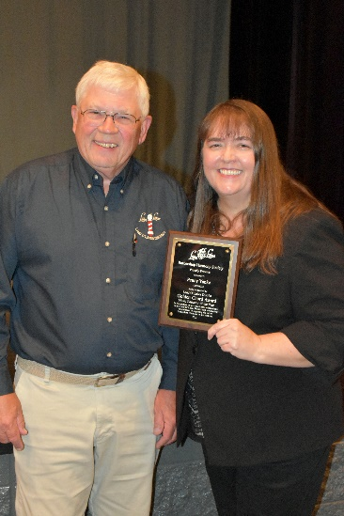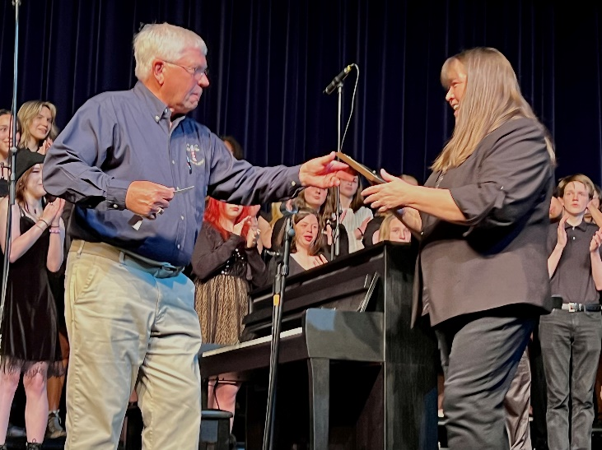
Pictures of Jim Rasmus, presenting the Golden Chord Award to Penny Yanke.

