My Name is:___________________________ My Goal is:___15__boxes
Country Cookie has been serving St. Joseph and surrounding communities with fresh baked from scratch cookies since 1986.
Options
a. 1 dozen Holiday Sugar Sugar
b. ½ dz sugar sugar with a Hazel’s Coffee House Potful
c. Just Coffee Potfuls
All funds raised go towards Performing Arts Association of St. Joseph
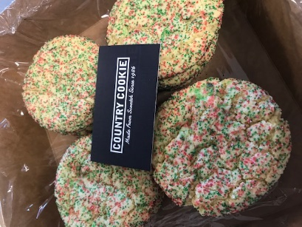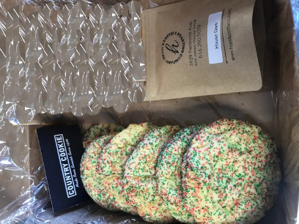
Holiday Sugar Sugar
½ dz Sugar Sugar
House Coffee
Coffee House Blend
Name Printed | Address | Phone Number | QTY  $20 | QTY  $15 | QTY  $3 | Total $$
Name | Address | Phone | $20 | $15 | $3 | Total $$
Total Sold

Orders and money are Due by Wednesday December 3th. Cookies will be delivered beginning December 8-10th

