December 2022

**Latest News/Quarterly Update**

As the year draws to an end, the handover to Maunder Taylor is firmly underway, and we are looking forward to working with the new managing agents from 3rd January,2023.

We will be circulating the relevant contact details to you all in the New Year.

It has been brought to our attention that several of you are not clear on the process for addressing leaks, electrical issues within the individual flats. We are briefly outlining the process below in the New Website section. Please make note of the details, as a failure to do so could result in you incurring unnecessary high costs.

**Special Thanks to Mihaela**

We would like to say a BIG ‘THANK YOU’ to our Caretaker Mihaela.

During our recent cold snow spell, Mihaela worked tirelessly to ensure our main outdoor areas and paths were kept clear of snow, keeping us safe and moving. Great Job!

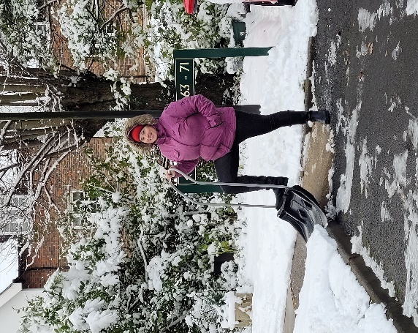

**Resolution to update Articles of Association**

Thank you to all leaseholders that supported this crucial amendment.

For those unable to attend we can confirm that we achieved the required 75% to pass the resolution at the recent shareholders meeting.

The votes have been independently verified and we will implement these changes

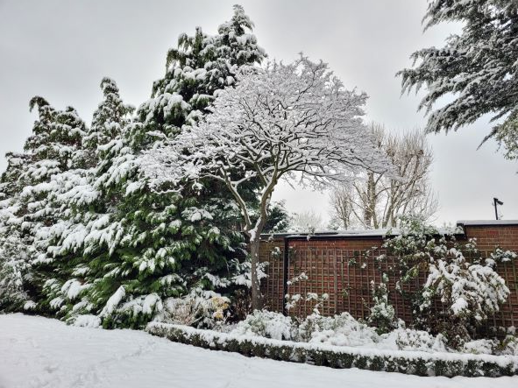

**Electrical project**

We have completed the external electrical update.

All the lights are now LED and we have new tall lights at the front of the estate.

Total Cost approximate £6000

**New Website coming soon**

We mentioned at the recent shareholders meeting that we are working on a website for Greenacres, in conjunction with Martin Aaron. It will contain useful information including details of tradesmen, important contact details and the processes/guidelines to help with leaks and electrical works in individual flats. We hope to have it ‘live’ by spring 2023.

**In the meantime, should you have a leak or an electrical issue in your flat it is the leaseholder’s responsibility to contact a plumber, electrician to help resolve/fix. Call outs and repairs are NOT met through the service charge account and are the sole responsibility of the individual leaseholder (unless it involves the main stack running through the flat.**

**Damp ground floor reception in all blocks**

We are aware of the damp course issue in the communal areas of the blocks.

We will appoint a surveyor in the New Year to assess the situation and clarify whether the costs are part of service charge or for leaseholders individually.

*Finally, we would like to wish all our residents a peaceful and relaxing season ahead and a healthy and prosperous New Year.*

**Directors: Alan Harris (Chair), Robert Lewis and Seema Shah**