March 2023 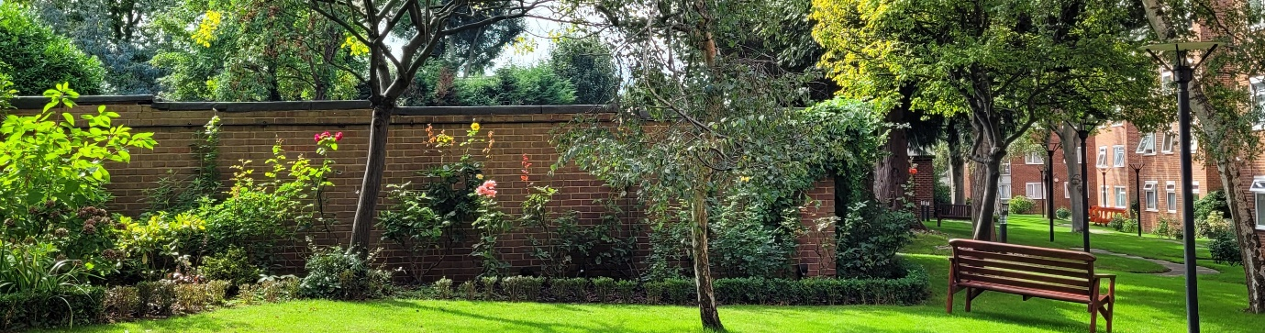
Latest News/Quarterly Update
We are now in the process of reviewing some of our fixed costs and where appropriate we will be reviewing the service agreements. As a priority we are looking at the levels of security around the estate. We have a very large estate with multiple entry and exit points. This is quite a challenge, and we will be tightening the security where possible. This is not meant to alarm anyone but given the times we find ourselves in, we think it prudent that we should look at securing the site as best we can.

New Website
We are in the final stages of preparing the Greenacres Website. We are on target to getting it ‘live’ by spring 2023. We hope it will provide some useful information and a sense of community. If you have any constructive comments, please email one of the directors.
A SPECIAL THANKS to Martin Aaron for kickstarting this visionary project. Martin started working on the website whilst he was a director and has been helping us get it to the finishing line.
Maunder Taylor
We would like to welcome Maunder Taylor to Greenacres. Thank you for your hard work over the 3-month transition period. We realise it has been a challenge.

New Parking Control
You will all have received notices from Maunder Taylor with regards to the new company. Please take the time to read the details and submit the forms to the Managing Agents

Authorised Essential Works
NEW CCTV – Our existing equipment needs overhaul. We have asked Maunder Taylor to contact relevant operators to receive quotes and recommendations.
DOOR ENTRY SYSTEM to Blocks 1, 2, 4 &5 – Only block 3 is adequate. We will be issuing section 20 in due course.

KING CHARLES III CORONATION PARTY
We are planning to have our own celebration at Greenacres on Monday 8th May, on the back lawn. We have a small group of volunteers and if you would like to help/get involved please contact any one of the directors. It is open to residents and leaseholders. Looking forward to seeing many of you on the day.
All we need now is some sunshine!


Community groups
Gardening Club – If you would like to join our resident gardening club please get in touch. It is a great way to make friends and get some exercise! To join message Alan- 07557 511669

Residents WhatsApp Group - Open to all residents.
To join, message Robert 07887 943599 we need your name, flat number, and mobile number.

Directors: Alan Harris (Chair), Robert Lewis and Seema Shah

