September 2022 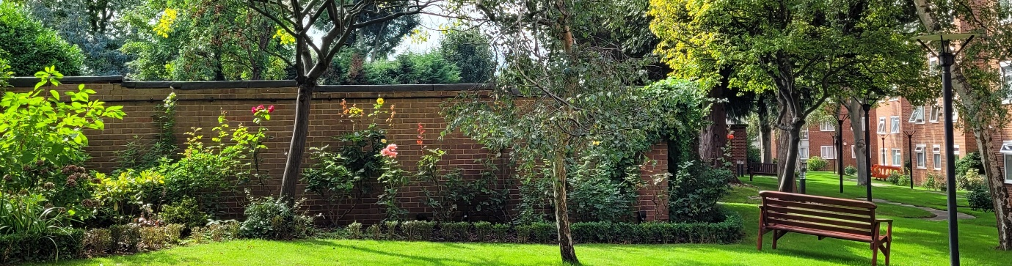
Latest News/Quarterly Update
Welcome to our first newsletter. We are planning to send quarterly publications to keep you informed of the news and developments at Greenacres. We intend to use this newsletter as one of the main channels of communication between the directors and the lessees through the year. It will provide you with information on essential works or repairs that are being carried out and projects we are considering/reviewing. We hope it will also encourage a more open dialogue between us and promote the much-needed transparency.

Gardening Club
As we mentioned to you during our last meeting in July, we were keen to promote a more harmonious community, and with that in mind we have launched our gardening club. The benefits of gardening and being outdoors cannot be overstated as recent studies have shown. If you would like to get involved, you are welcome to come along.
Beautiful flower beds are a bonus for the rest of us! Special thanks to our green fingered volunteers.
To join message Alan- 07557 511669

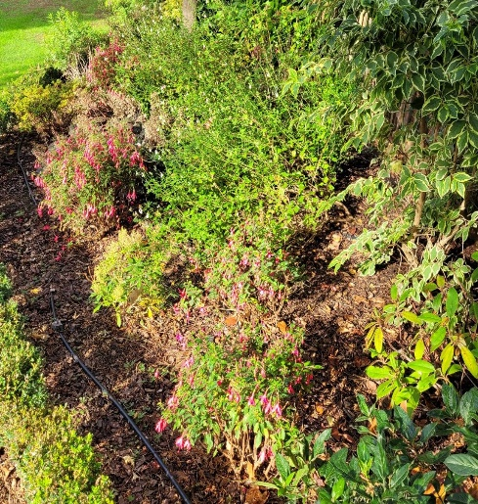
Resolution to update Articles of Association
Shareholders Discussion 29th-30th September
Thank you to all those that have responded with your preferred session. If you are unable to make the sessions listed, please email PGA with your preferred date and time, we will try and accommodate as many as possible.
We need 75% or 54 flats to vote in favour of passing the resolution to update our Articles. THIS IS IMPORTANT. PLEASE RESPOND.
Residents WhatsApp Group
We have also set up a residents WhatsApp group to facilitate information flow between our residents. If you would like to be part of this group and have not yet been added to the group, please get in touch.
To join, message Robert 07887 943599 we need your name, flat number, and mobile number.
Please

Authorised Essential Works
We are not authorising any works other than those that are essential. The safety of the residents is our primary concern, therefore we have approved the following works.
The Paving stones/walkways had become uneven, and some people have already fallen. This has been completed. Cost- £1,500
The security of the estate has been compromised as the CCTV was not functioning. We have authorised. Cost - £5,000
The unfinished sleepers at the front. We have authorised the completion. Cost- £3,000
Several of the external light fittings failed a recent test, we have authorised works to rectify and confirm ALL fittings are compliant.
Cost- £2,400

Electrical project
We are all facing excessive energy bills this winter, we are trying to reduce the estates cost by implementing energy savings, savings that will reduce our costs but not affect the security of residents.
Over the next few weeks, we will be experimenting with turning off lights to the rear and reducing bulb outage. These are only temporary changes and can be reversed. We apologise for any inconvenience caused whilst works are carried out.

Review of the Estate and the 5-year plan
We have completed our review of the contracts and expenditure of the estate and are creating a 5-year plan of works using an ‘Estate MOT Survey’ carried out in 2020 by our predecessors. The cost of this survey was £1800.
We will be reporting on both during our shareholders meeting in Autumn.

Finally, we would like to say to those lessees that continue to interrogate or interfere with the estate’s contractors, (you know who you are), PLEASE STOP!
It is not only unprofessional, it also undermines the board.

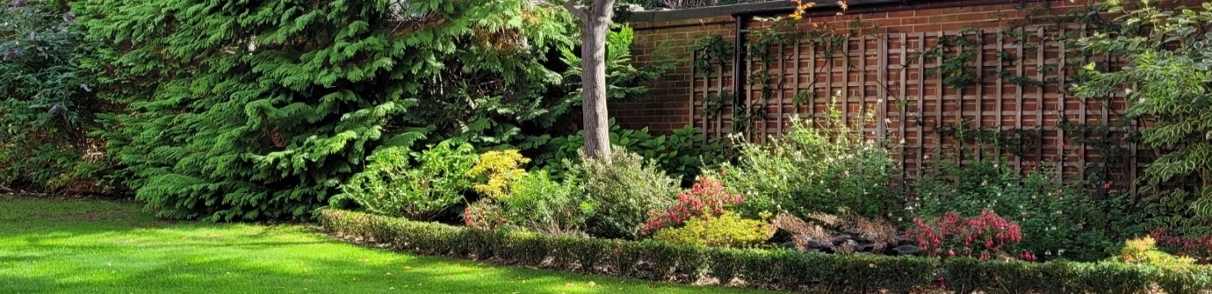
Directors: Alan Harris (Chair), Robert Lewis and Seema Shah

