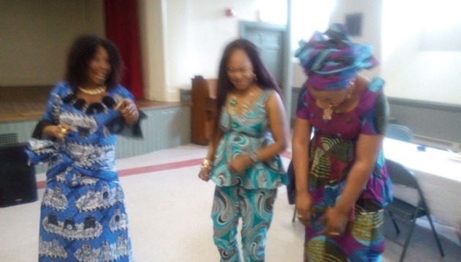

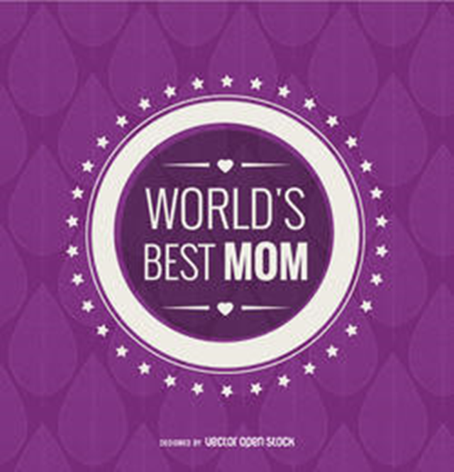

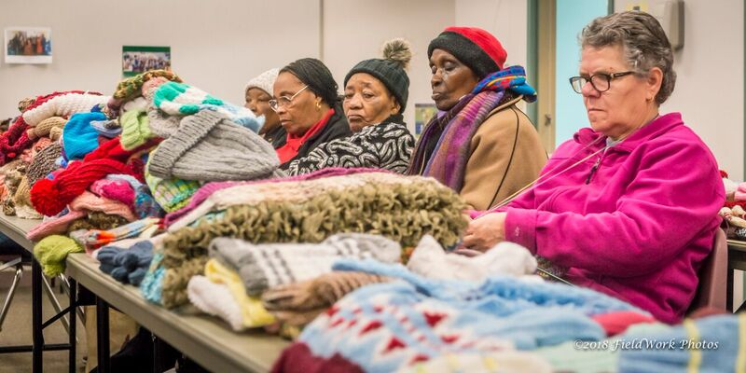

Please join us as we celebrate
International Mother’s Day in Manchester!
Hear from a panel of local international mothers, children’s activities and lunch!
Families are Encouraged!
Saturday, May 12th, 2018 11:00 am -12:30 pm
Donation Appreciated: $5 per person/$20 per family
SNHU Center for New Americans at the YWCA NH
72 Concord Street, Manchester, NH 03101
For more information, please contact 603-623-8968
Sponsored by: Victory Women of Vision, YWCA NH and SNHU Center for New Americans

RSVP by Thursday, May 10th Tickets available online at EventBrite:
https://www.eventbrite.com/e/international-mothers-day-tickets-45459174615?aff=erelexpmlt

Victory Women of Vision 25 Lowell St. Suite 307 Manchester, NH 03103 - victorywomen12@gmail.com
SNHU Center for New Americans / YWCA NH 72 Concord St. Manchester, NH 03103

