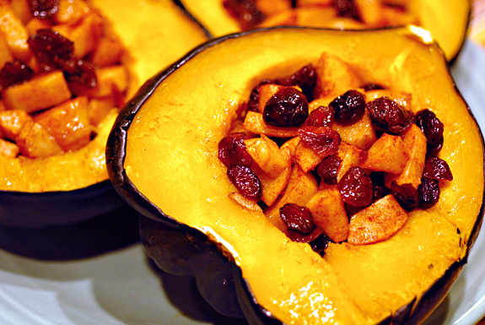  ACORN  - Squash  Application  Acorn squash may be peeled, but are more often cooked with their skin-on at 375* for 50-60min, face down.  - Peel & dice, or cut into slices along the natural ribs; toss with oils, spices or herbs and bake or roast.  - Serve with or without the skin.  - Cooked squash may be pureed and added to soups, stews, risotto, cakes or other baked goods.  - Stuff and bake halves with meats, cheese, grains or other vegetables.  Acorn squash will keep at room temperature for many weeks. Best kept in a cool, dry place for winter storage. | MILDLY SWEET  Somewhat Dry Texture  Averages: 5-8” Long 4-5” Across  Maturity: Dark Green with Splashes of Golden Yellow  Vitamin C, B6, Magnesium and Potassium  The Pumpkin Stand  7844 State Rte 414  Ovid, NY 14521  www.ThePumpkinStand.com  OPEN Daily 10AM-6PM  Labor Day - Halloween

