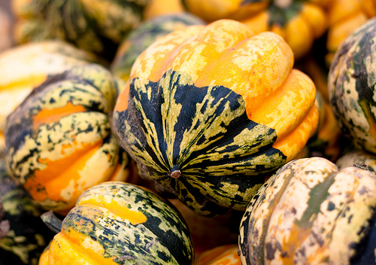  cARNIVAL  - Squash  *Sweet Dumpling/Acorn Hybrid  Application  The Carnival squash can be steamed, boiled or sautéed. Although the most effective way to achieve optimal flavor and texture is by roasting it.  Bake at 400 degrees for 30-35min  - It can be roasted whole, cut in half or into pieces.  - It can also be utilized as an edible vessel, as its size often lends itself to individual sized serving portions.  - Carnival squash also pairs well with; pork, lamb, other roasted winter vegetables, maple syrup, toasted walnuts and pecans, and aged cheeses.  Best stored in a cool, dark space for up to a month.  Also, highly ornamental to any table or bowl display! | SWEET  Soft with nutty nuances.  Averages 4”- 5” 1.5 - 2 lbs  Maturity: Yellow, Green and Orange  Vitamin A, C, Potassium, Magnesium, Calcium, Folate, Omega 3 & 6 Fatty Acids  The Pumpkin Stand  7844 State Rte 414  Ovid, NY 14521  www.ThePumpkinStand.com  OPEN Daily 10AM-6PM  Labor Day - Halloween

