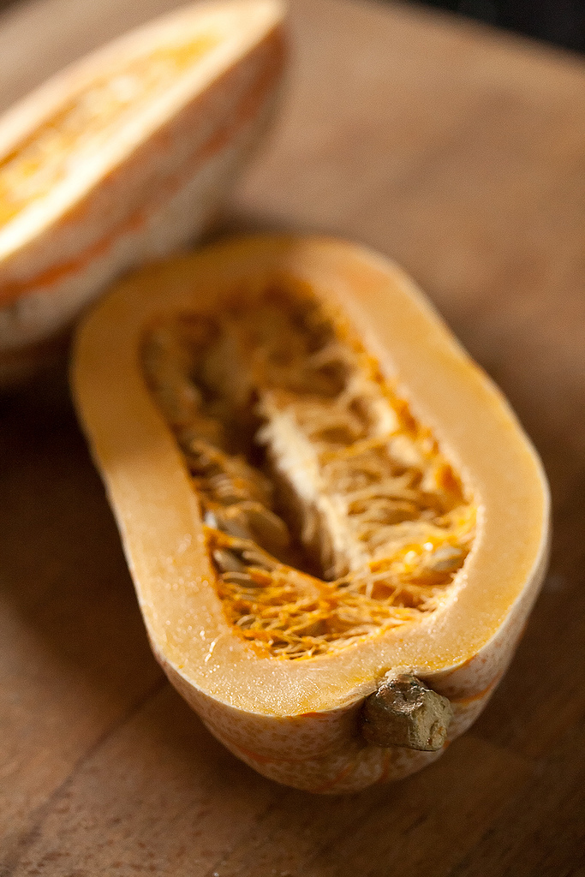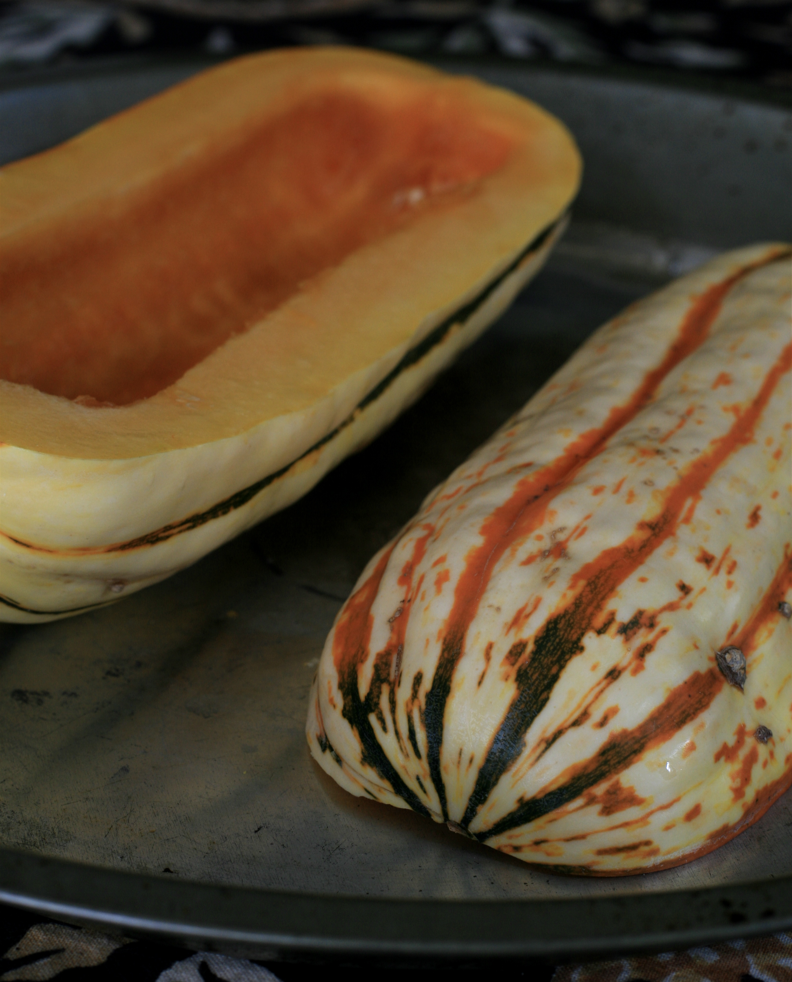  Delicata  - Squash  Application  Delicata squash has a sweet potato like flavor with edible skin which is easy to slice.  Bake at 400 degrees for 25-30min.  - Stuff with grains, meats or cheese, for baking.  - Slice into rings or cubes and braised, stewed, sautéed or roasted.  - Slice in half and back face down with oil or water on bottom.  Delicata squash are a winter variety and will keep well at room temperature for several weeks. | SWEET  Fine Sweet Potato – like flavor with Edible Skin  Averages 3”x7”-9” 1.5 to 2 lbs.  Maturity: Cream w/green and golden strips  Vitamin A, C, B, Potassium and Soluble Fiber. *Rich in Beta Carotene  The Pumpkin Stand  7844 State Rte 414  Ovid, NY 14521  www.ThePumpkinStand.com  OPEN Daily 10AM-6PM  Labor Day - Halloween

