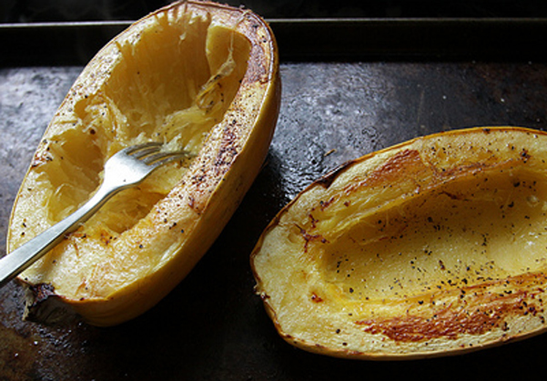  Spaghetti  - Squash  Application  Spaghetti squash has a hard rind and unique interior flesh which separates into pasta-like strings when cooked. Whole or halved it can be steamed, baked, roasted or microwaved.  Bake at 400 degrees for 35-40min.  - Once cooked, the flesh can be shredded with a fork to make the stringy squash noodles.  - Cooked it can be sautéed with complimentary ingredients or added to casseroles, gratins, and bakes.  - Served in its hard rind, Spaghetti Squash can be topped with or tossed with sauces, vegetables, meats, cheeses, and herbs.  - Complimentary ingredients include tomato, onions, garlic, greens, fresh herbs, cream, parmesan, mozzarella and feta cheese, ground beef, Italian sausage, and pancetta.  Spaghetti squash will keep for a month at room temperature. Cut squash is best used within two days. | MILD Flavor  Tender with slight crunch/ Stringy like Angel Hair Pasta  Averages 4 – 8 lbs  Maturity: Yellow  Vitamin A, Folate, Folic Acid, Beta Carotene, Potassium and Fiber  The Pumpkin Stand  7844 State Rte 414  Ovid, NY 14521  www.ThePumpkinStand.com  OPEN Daily 10AM-6PM  Labor Day - Halloween

