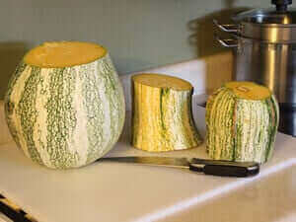  Cushaw Squash  History  The green-striped cushaw is a pear-shaped squash that is usually used fully ripe as a winter squash, but can be eaten when very young as a summer squash. Originally from tropical America (Mexcio), it has a mildly sweet taste and behaves like a pumpkin or delicata squash when it is cooked.  Application  Best cubed and baked on a baking sheet with olive oil at 400* for 25-30 min.  - This rich flavor goes well with turkey, pheasant and venison.  - Cushaws are also the favorite pumpkin pie filling throughout the South.  - The nutritious seeds are toasted then ground into flour or eaten whole.  - Good for baked goods such as muffins, brownies and cakes. They can be made into dairy products such as cushaw yogurt, cushaw puddings and even cushaw ice cream.  - Leftover squash is a vitamin-rich feeder for livestock, including sheep and chickens.  Cushaw squash will keep at room temperature for many weeks. Best kept in a cool, dry place for winter storage. | Slightly Sweet  Mild flavor with a hint of smokiness  Averages: 12-18” Long 10-20 LBS  Maturity: Typically Green & White Stripes  Vitamin C & A (Which is good for the immune system!)  The Pumpkin Stand  7844 State Rte 414  Ovid, NY 14521  www.ThePumpkinStand.com  OPEN Daily 10AM-6PM  Labor Day - Halloween

