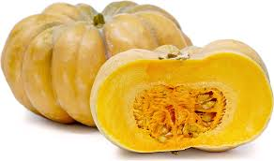  FairytaLE  - Pumpkin  Application  Fairytale pumpkins are best suited for both RAW and cooked applications such as sautéing, baking, boiling, and roasting.  - The pumpkin should be sliced from the center, and raw slices can be used in salads, consumed as a snack similar to cantaloupe, or used as a garnish on top of main dishes.  - When cooked, the pumpkin can be roasted and blended into soups, stews, curries, casseroles, butter, cream-based sauces, and pasta dishes. Fairytale pumpkins are also used in a variety of desserts and baked goods such as pies, tartlets, muffins, cakes, and cookies.  Bake at 400 degrees for 90 – 120 min.  - To prepare, cut like a pie.  - Scoop seeds and wrap in foil.  - Place in baking dish covered or flat on baking sheet.  Store up to 9 months in a cool and dry location. Once diced stores up to 2 weeks in the refrigerator. Fairytale pumpkin slices can also be frozen up to 6 months. | SPICY SCENT MILD/Sweet Flavor  Enjoy RAW or Cooked: Smooth, creamy and tender  Averages 15 - 20 lbs  Maturity: Dark Gree to Dark Tan and Dry Tan Stem  Vitamin A & C, Beta Carotene, Potassium/Mag, Omega-3, B-complex and copper  The Pumpkin Stand  7844 State Rte 414  Ovid, NY 14521  www.ThePumpkinStand.com  OPEN Daily 10AM-6PM  Labor Day - Halloween

