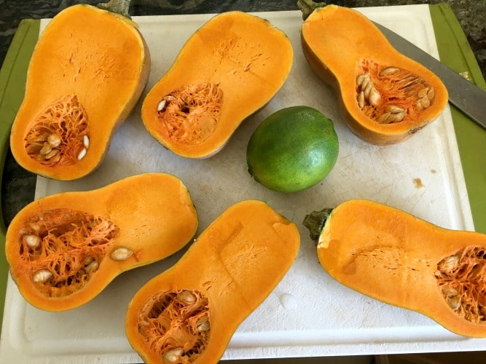  This Photo by Unknown Author is licensed under CC BY-NC-ND  Honeynut  - Squash  Application  Honeynut squash is a bit easier to prepare and cut than butternut squash thanks to the smaller size.  Bake, boil or roast Honeynut squash. However, the recommended preparation method is roasting, which allows the sugars in the flesh to caramelize, and maximizes the flavor profile of the squash.  Bake at 400 degrees for 25-35min.  - Honeynut squash can be used in any recipe calling for butternut or other winter squash varieties.  Store Honeynut squash on the countertop for up to a month, any peeled or prepared portions can be refrigerated for up to a week. Raw, cut Honeynut squash can be frozen for up to three months.  *Cornell Developed – Butternut/Buttercup Hybrid | VERY SWEET  Thick/Smooth Rich Flavor  Averages 2” x 5” 1 – 1.5 lbs  Maturity: Dark Tan/Burnt Orange  Vitamin A, B, Beta Carotene, Folate, Iron, Zinc, Copper, Riboflavin and Potassium.  The Pumpkin Stand  7844 State Rte 414  Ovid, NY 14521  www.ThePumpkinStand.com  OPEN Daily 10AM-6PM  Labor Day - Halloween

