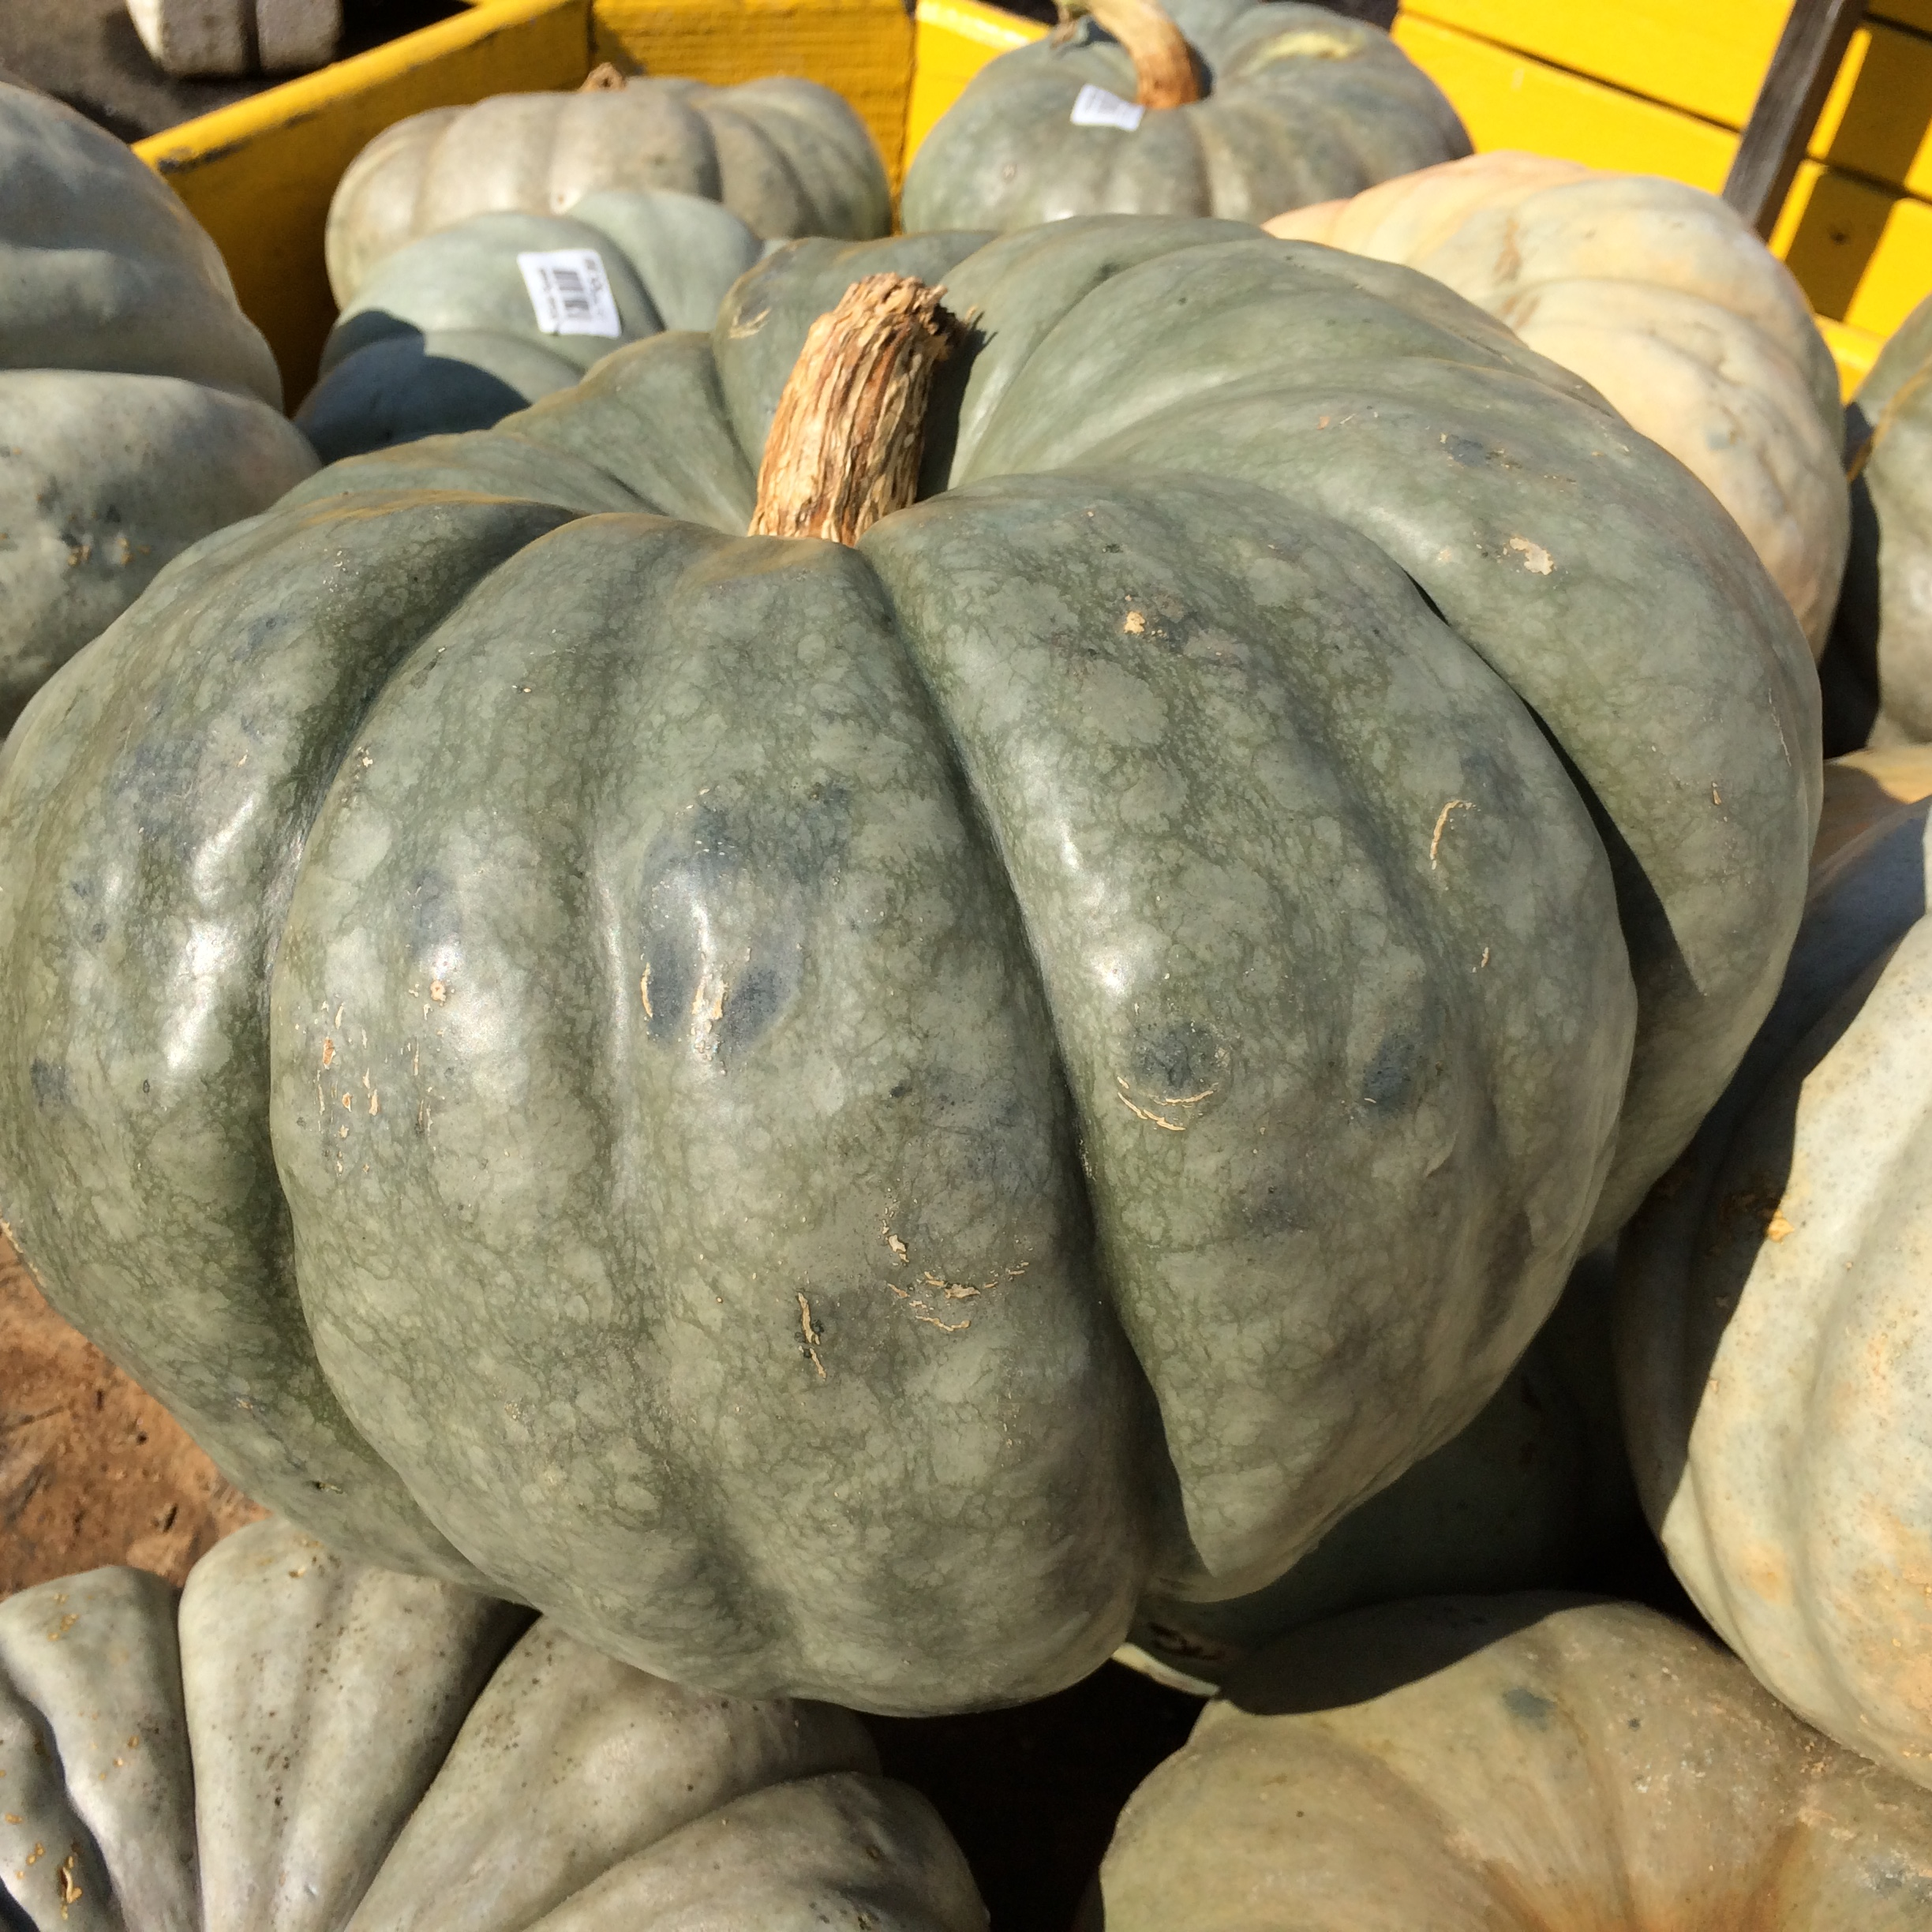  jARRAHDAL  - Pumpkin  Application  Jarrahdal Pumpkin is an edible ornamental. It has a sweet flavor which lends itself well to pie fillings, scones and cakes.  - Alternately you can use roasted pieces in risottos, salads and pasta dishes.  - Cook till soft and use as a filling for ravioli or incorporate into dough when making gnocchi.  - Dice and add to curries, soups and stews.  - Blend with a Butternut to feed a large crowd/guest.  Bake at 400 degrees for 55 – 90 min.  To prepare, cut like a pie. | SWEET  Smooth and Flavorful  Averages 12 – 18 lbs  Maturity: Dusky Blue/Gray or Green  Vitamin A Beta Carotene  The Pumpkin Stand  7844 State Rte 414  Ovid, NY 14521  www.ThePumpkinStand.com  OPEN Daily 10AM-6PM  Labor Day - Halloween

