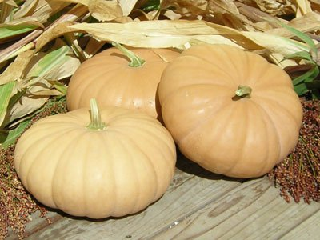  long island cheese  - Pumpkin  Application  The Long Island Cheese pumpkin is known for its culinary attributes but is also recommended as a healthy dietary addition for household pets. When fed raw to chickens it’s known to help support healthy egg production in the winter months.  Bake at 400 degrees for 45 – 55 min.  - To prepare, cut like a pie.  - Roast, dice and add to curries, soups and stews.  - Commonly used for pies and various bake goods.  Long Island Cheese pumpkins are excellent keepers and can be stored in a cool, dry, dark place for up to three months. | MILD/SUBTLY SWEET  Smooth, Fine Grain Texture - Edible Seeds  Averages 6 – 10 lbs  Maturity: Tan with Slight Ribbing and Dry Stem  Vitamin A, C, Potassium and Beta Carotene  The Pumpkin Stand  7844 State Rte 414  Ovid, NY 14521  www.ThePumpkinStand.com  OPEN Daily 10AM-6PM  Labor Day - Halloween

