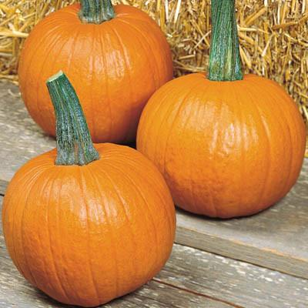  Mystic  - pie PUMPKIN  About  These round to flattened fruit are beautiful as ornamentals and delicious when baked in pies. They have thick hearty stems and a thick wall cavity.  *NOT ideal for carving.  Bake at 400 degrees for 45 – 55 min.  - Slice open in half or like a pie.  - Puree cooked pumpkin and use to make pumpkin ice cream or pumpkin pie.  Store in a cool and dry place and use within a few months. | MILD SWEET  Moist custard-like texture  Averages 8” x 6” 7 – 8 lbs  Maturity: DEEP Orange/ Small Brown Specks  Dietary Fiber, Vitamin A and Beta Carotene  The Pumpkin Stand  7844 State Rte 414  Ovid, NY 14521  www.ThePumpkinStand.com  OPEN Daily 10AM-6PM  Labor Day - Halloween

