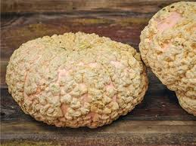  GALEUX d’EYSINES  - PEANUT SQUASH  About  During its growth period, sugars in the flesh begin leeching through the skin causing unique, peanut like shells. The more peanut like shells, the sweeter the squash.  Application  The Peanut Squash can be roasted, grilled, baked, or sautéed. Boiling and steaming should be avoided due to water retention.  Bake 400 degrees for 45-55min.  - Peanut Squash is ideal when cooked and pureed for use in soups, sauces, preserves, or pies.  - The seeds are also edible and can be roasted or baked and eaten alone or in a granola mix.  Perfect for your ornamental displays. Stores for one month in a cool, dry space. | SWEET Nutty Flavor  Smooth Velvety Texture  Averages 10 – 12 lbs  Maturity: Salmon-Peach Skin with Peanut like shells  Vitamin A, C, Fiber, Potassium & Beta Carotene  The Pumpkin Stand  7844 State Rte 414  Ovid, NY 14521  www.ThePumpkinStand.com  OPEN Daily 10AM-6PM  Labor Day - Halloween

