Protecting Our Kids in the Digital World

On Sunday, November 9th members of the Illinois Attorney General's Office , Internet Crimes Against Children (ICAC) Task Force will present to our parents and
community on the following topics:
Impact of Screen Time Predatory Tactics Sexting & Sextortion Safety Resources Reporting

The Internet Crimes Against Children (ICAC) Task Force delivers training to children, teens, and parents/ guardians that provide valuable information on how to stay safe and avoid online risks.
Hosted by:

Holy Cross Catholic Church
Date & Time:

Sunday, November 9th @ 6:00pm
Location:
724 Elder Lane, Deerfield, IL Community Room
All adults are welcome.
Some topics may be sensitive.






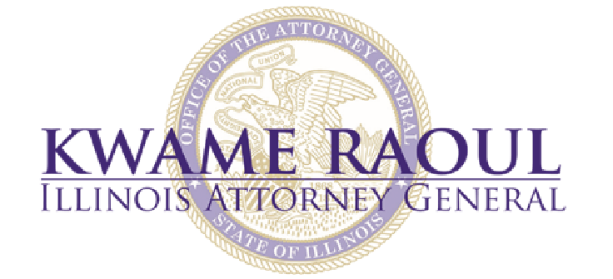
For additional resources visit: http://www.onlinesafeonlinesmart.com/

