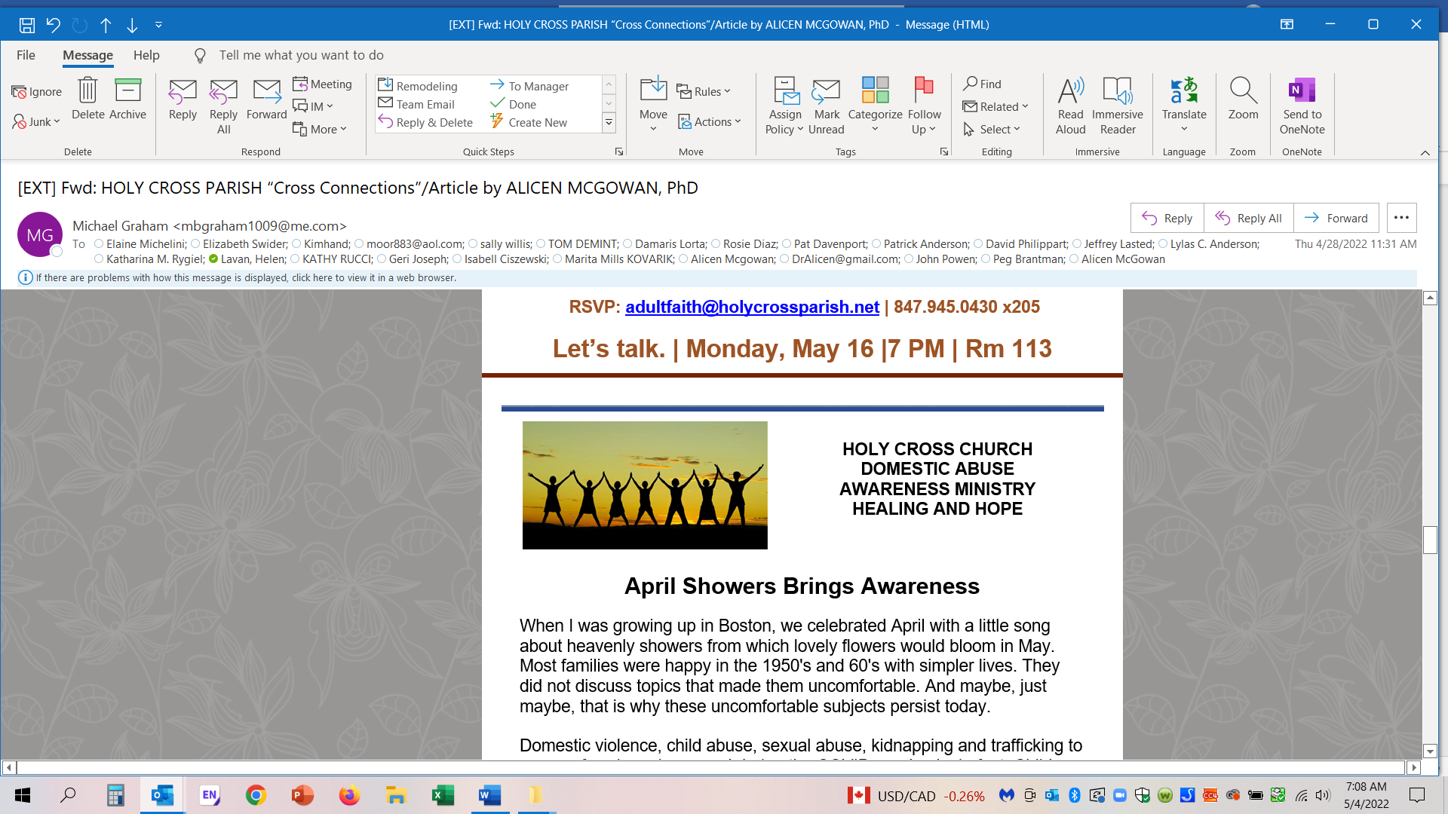
From Cross Connections April 27,2022
April Showers Brings Awareness

When I was growing up in Boston, we celebrated April with a little song about heavenly showers from which lovely flowers would bloom in May. Most families were happy in the 1950's and 60's with simpler lives. They did not discuss topics that made them uncomfortable. And maybe, just maybe, that is why these uncomfortable subjects persist today.

Domestic violence, child abuse, sexual abuse, kidnapping and trafficking to name a few, have increased during the COVID pandemic. In fact, Child Maltreatment is a pandemic itself. Two parallel pandemics, yet only one is being addressed. April has been designated as Prevent Child Abuse month, so April is no longer just about rain, but also serves as a reminder that 7.5 million calls were made to the Domestic Violence hotline last year, which is estimated to be a 25-50% underrating. The majority of these cases had child witnesses, many of whom were injured trying to defend a parent being beaten.

At Holy Cross Parish in Deerfield, we decided to face an extremely difficult subject- domestic abuse - and the collateral damage of children hurt by DA in their homes. Child abuse can be violent (hitting, bullying, depriving the child of peaceful enjoyment by restraining them and many other violent acts).

Abuse also comes in many other forms inside the home; psychological harassment, unreasonable discipline & punishments, malicious financial restraints, bullying, spiritual isolation, educational & recreational deprivation, and prevention of typical socialization.

The question becomes, how do you know if someone in your neighborhood or “social bubble” is being abused?

It can be easy to determine!

Just take a breath, observe behaviors, be brave, and tackle the situation at hand. If you witness aggressive or abusive behaviors, especially if there is suspicious yelling, screaming, or unexplained loud crying - call 911. You can call anonymously and you may save a life! If there is a child in the home call DCFS and make an anonymous report. The mantra at DCFS is “make the call, just make the call”. They will sort things out.

Also, If you see a child wearing out of season clothes, clean your closets. Bring over your child's outgrown jackets, boots etc. and give them to the needy child's parent. If you are allowed to do so- look around inside their house and determine if they need something (food, clothing, money). Fill the need!

Sometimes just having a cup of coffee and being a willing ear to listen is a first step.

If you have a friend or family member who is in an abusive relationship - suggest that they call A SAFE PLACE at 847-731-7165 (an organization in Lake County providing services exclusively for victims of domestic abuse or human trafficking.) WINGS is another non-profit that serves survivors of domestic abuse in our area.

An option locally is to call the local POLICE Dept. Social Services Division (in Deerfield area 847-794-7511, to obtain referrals for services such as counseling, in person crisis intervention, or advice regarding orders of protection.) Our free Holy Cross DOMESTIC ABUSE MINISTRY Website is a very helpful additional resource at: https://domesticabuseholycross.org

The bottom line is that we have more Domestic Violence and Child Maltreatment in Lake County than you think. But effective assistance & personalized services are readily available at no cost.

Jesus did not demonstrate turning His back on those in need. In fact, He urged us to feed the hungry, clothe the naked, and get involved as our brother's keepers. We do not have to sit back and wait for others to step up. We all can help. Just be intentional. Each of us is capable of changing lives for the better. We need to protect our children from abuse, and discourage violence in any form.

As Anne Frank wrote so eloquently, "How wonderful it is that nobody waits a single moment before starting to improve the world".

God Bless! Dr. Alicen
A-J McGowan LCPC PhD, RPT-S, CAS,
Child Trauma/Domestic Violence Specialist, and Author “We Hid Under the Table” and “We Survived, in spite of the systems” both available on Amazon. Recently served on the Governor’s Advisory Board to DCFS.

