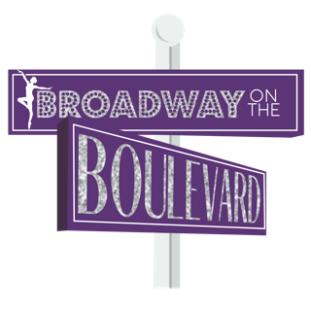

PHOTO/VIDEO/DIGITAL IMAGE CONSENT

I _______________________________ hereby grant consent to Broadway on the
Boulevard and its staff or contracted third parties to use photos, videos, digital images and/or audio recordings of ____________________________________ for use in studio promotional materials. This may include use on social media, advertising material, tv ads, our website or other means.

The safety of our students is our main priority. Please be sure that we will use all possible means to protect our students and their personal identities.

_____________________________________________ ________________________________
Parent/Guardian Signature Date
