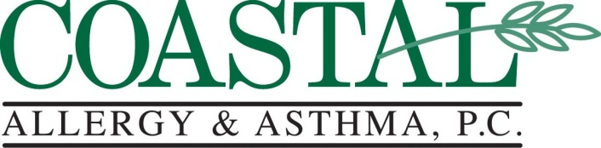
Specializing in the Treatment of Adult and Pediatric Allergic Disorders

Bruce D. Finkel, M.D. | Brad H. Goodman, M.D.
Monica Rama, M.D. | Timothy J. Dare, Jr., PA-C
Aspirin Avoidance/NSAID Avoidance

Aspirin and the structurally related group of medicines known as non-steroidal antiinflammatory drugs (NSAIDs) are common causes of allergic reactions such as hives. Aspirin additionally may worsen asthma in aspirin sensitive asthmatics and contribute to growth of nasal polyps. Aspirin and NSAIDs are commonly used to treat muscle aches and sprains, headaches, and arthritis. In addition, many of these medications are combined in various over the counter medicine preparations such as alka-seltzer, and other cold and flu remedies. If you are sensitive to these drugs, then avoiding them may decrease or alleviate your allergic type reaction.
Commonly used medications containing aspirin or NSAIDs are listed below:
Anacin | Ecotrin | Correctol
Advil | Excedrin | Motrin
Alka-seltzer | Feldene | Naprosyn
Aleve | Goody's | Nuprin
Bayer | Ibuprofen | Orudis
Bufferin | Indocin | Actron
BC Powder | Midol
This list is not exhaustive. If you have been advised to avoid aspirin and NSAIDs, please check with your pharmacist prior to taking any prescription or over the counter medication including eye drops and topical creams or gels.

People who are sensitive to aspirin and NSAIDs can frequently safely take the nonprescription medication acetaminophen (Tylenol) and a prescription medicine, trilisate, for minor aches and pains.

Related allergies

Approximately one-third (1/3) of patients with a hypersensitivity to aspirin and NSAIDs develop similar symptoms after ingesting yellow dye #5, a common food coloring. Labels of all foods should be checked for this additive (also known as tartrazine). Foods containing yellow dye #5 should be avoided if your physician determines that you are sensitive to this substance, or to aspirin or NSAIDs.

