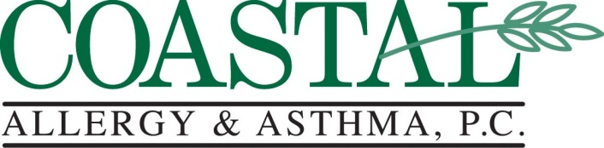
Specializing in the Treatment of Adult and Pediatric Allergic Disorders

Bruce D. Finkel, M.D. | Brad H. Goodman, M.D.
Monica Rama, M.D. | Timothy J. Dare, Jr., PA-C

Nasal Saline Lavage

- Hypertonic Saline Lavage- Mix 3/8 teaspoon of table salt with 3/8 teaspoon of baking soda in 8 ounces of water. Fill a bulb nasal syringe with the solution and squirt in each nostril 4 times. Repeat as needed.

- Normal Saline Lavage- Mix 1/8 teaspoon of table salt with 1/8 teaspoon of baking soda in 8 ounces of water. Fill a bulb nasal syringe with the solution and squirt in each nostril 4 times. Repeat as needed.

