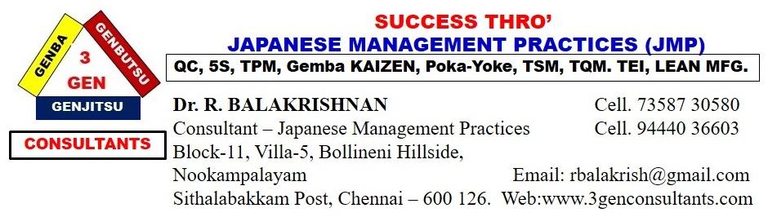

25 STEP STONES

TO REACH THE DESTINATION IN THE LEAN JOURNEY

|  |  |
| --- | --- |
| **S.No.** | **STEP STONE (TOOLS)** |
| **1** | **5S (Total Environment Management)** |
| **2** | **Andon** |
| **3** | **Bottleneck Analysis** |
| **4** | **Continuous Flow** |
| **5** | **Genba (The real workplace) visit** |
| **6** | **Heijunka (Level Scheduling)** |
| **7** | **Hoshin Kanri (Policy Deployment)** |
| **8** | **Jidoka (Autonomation)** |
| **9** | **Just-In-Time (JIT)** |
| **10** | **Kaizen (Continuous Improvement)** |
| **11** | **Kanban (Pull System)** |
| **12** | **KPIs (Key Performance Indicators)** |
| **13** | **3 Mu (Muda, Mura & Muri) elimination** |
| **14** | **Overall Equipment Effectiveness (OEE)** |
| **15** | **PDCA (Plan, Do, Check, Act) rotation** |
| **16** | **Poka-Yoke (Error Proofing)** |
| **17** | **Six Big Losses - Elimination** |
| **18** | **SMART Goals** |
| **S.No.** | **STEP STONE (TOOLS)** |
| **19** | **Root Cause Analysis (RCA)** |
| **20** | **Standardized Work** |
| **21** | **Takt Time** |
| **22** | **Total Productive Maintenance (TPM)** |
| **23** | **Value Stream Mapping** |
| **24** | **Visual Management System** |
| **25** | **Single-minute Exchange of Dies (SMED)** |

This is the right time to start your LEAN JOURNEY to reach your business destination ‘PQCDSM’ by stepping on the 25 STEP STONES.

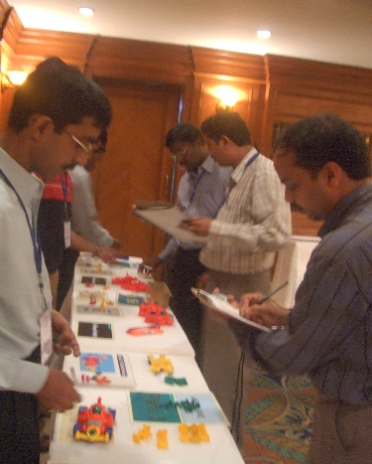 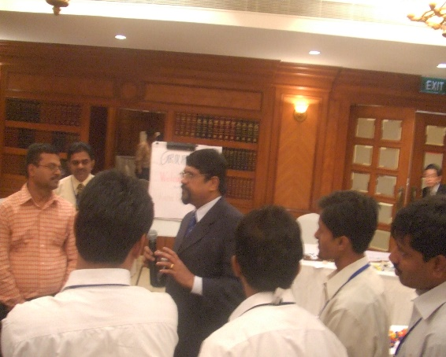

Do you like to know ……………..

1. What each step says?
2. How does it (Each step) help you?

Contact us to reach your business destination.

**Do you want to implement these 25 STEP STONES ….. Do not hesitate to call us.**

Dr. R. BALAKRISHNAN,

**CONSULTANT – Japanese Management Practices**

**Mobile: 7358730580 / 3444036603.**