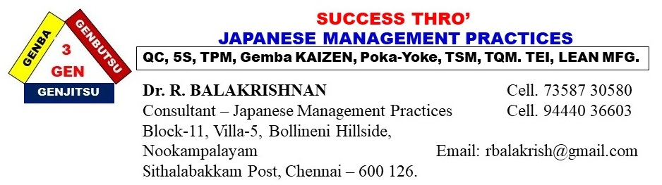

TPM IMPLEMENTATION METHODOLOGIES

**1. TPM** consist of EIGHT PILLAR approach.

1. Autonomous Maintenance Pillar
2. Individual improvement Pillar
3. Planned Maintenance Pillar
4. Quality Maintenance Pillar
5. Initial control Pillar
6. Office TPM Pillar
7. Education & Training Pillar
8. Safety, Health and Environment Pillar.

Each pillar practices should be implemented separately using circle leader and members.

2. Divide the total factory area into number of TPM Pillar CIRCLES (consider area or process or number of machines)

3. Group the CIRCLES under each pillar.

4. TPM ORGANIZATION STRUCTURE

TPM Champion

TPM Coordinator for all the pillars

TPM Pillar leader for a group of circles in each pillar

TPM pillar circle leader

TPM pillar circle members

5. Launching of TPM pillar activities – Publicity.

6. Identify the list of improvement activities required in each circle area based on the workplace assessment.

7. Preparation of KRA & KPI for each level and link TPM pillars objectives with measurable targets based on the current workplace assessment.

8. To implement the TPM pillars activities in a simple and successful way, divide the pillars under two phases:

Phase – 1:

1. Autonomous Maintenance pillar
2. Individual improvement pillar
3. Planned Maintenance pillar
4. Education and Training pillar

Phase -2:

1. Quality Maintenance pillar
2. Office TPM pillar
3. Safety, Health and Environment
4. Initial control pillar.

9. Conducting TPM implementation awareness training programs for each pillar, to the pillar leaders, pillar circle leaders and circle members.

10. Daily TPM pillar activities: Max. 15 minutes only

a) TPM Pledge - 2 min.

b) TPM Workplace standing meeting - 3 min.

* Pillar leader should talk about inconsistency in daily TPM activities and remedial actions.

c) 10 minutes TPM in their workplace.

11. Inviting SUGGESTIONS to improve the machine EFFECTIVENESS from all the circle members.

12. For each pillar - Preparation of ACTION PLAN to implement TPM pillar activities for each pillar.

13. Implementation of action plan

14. Daily checking by pillar leader using DAILY CHECKLIST (Self Audit)

15. Weekly TPM Progress Review Meeting – Pillar leader should conduct

for 30 to 45 minutes.

16. Training and certification to the TPM pillars internal auditors to improve the auditing methodologies.

17. Monthly internal auditing by the TPM internal auditors using Audit Checklist.

18. Audit feedback to each circle leader from the internal auditors.

19. Audit feedback correction report from the circle leader.

20. Use TPM Pillar tracker board to monitor the machine / equipment performance.

21. Measuring the TPM activities result against the TPM objectives with

measureable target.

22. Preparation of TPM pillar Manual to sustain the TPM Pillar activities.

23. Recognizing the Best performers by conducting inter zone

competition.

Look forward to implement the above TPM practices for improving P,Q,C,D,S, E & M in your factory.

Best regards



**Dr. R. Balakrishnan**

Principal Consultant – Japanese Management Practices

Mobile: 7358730580 / 94440 36603

Email: [rbalakrish@gmail.com](mailto:rbalakrish@gmail.com)