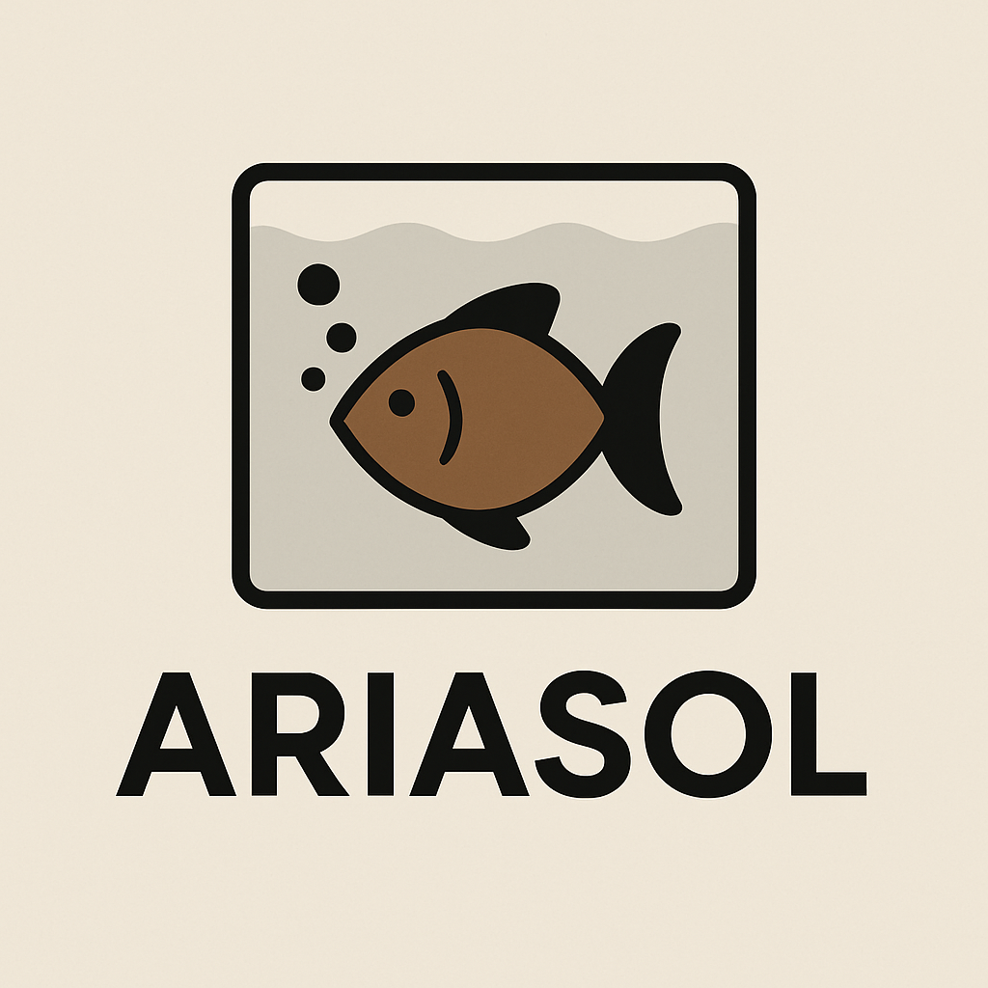
Congratulations on the purchase of your new Ariasol Classroom Aquarium Kit.
Enclosed you will find the following:
- A complete Owners Manual for your new kit.

