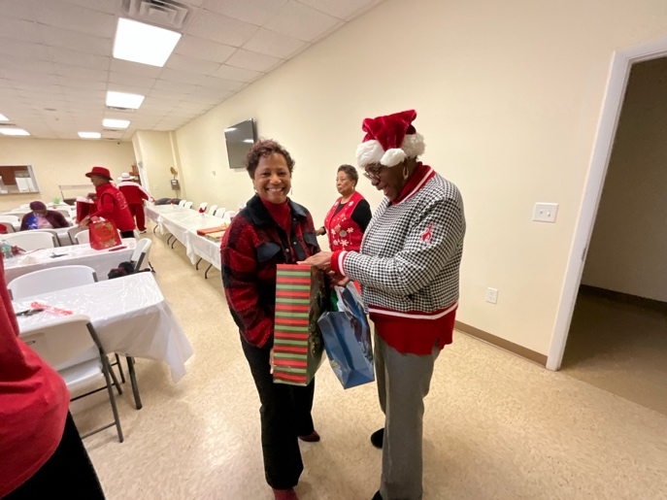

BCDST Senior Citizens Dinner – at St. James Baptist Church – Rev. James Smith, Pastor