New Hampshire Arms Collectors, INC.  Militaria & Cartridge Show  Ammunition, Reloading supplies, Militaria, Edged weapons, and Firearms related items  (No firearms: antique or modern)  Saturday, October 17th, 2026 (One day only)  Hours: 9:00AM to 3:00PM Admission: $10.00  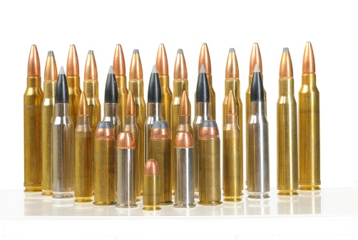60 Tables 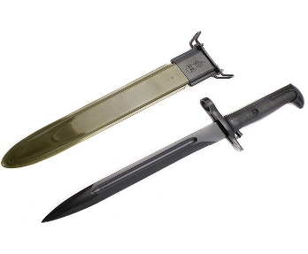  Location: I.B.E.W. hall, 48 Airport Rd. Concord, NH.  For more info. Go to www.nharmscollectors.org  Free admission for NHAC members and early admission  Half price admission for IBEW members with ID  Buy Sell Trade |  | New Hampshire Arms Collectors, INC.  Militaria & Cartridge Show  Ammunition, Reloading supplies, Militaria, Edged weapons, and Firearms related items  (No firearms: antique or modern)  Saturday, October 17th, 2026 (One day only)  Hours: 9:00AM to 3:00PM Admission: $10.00  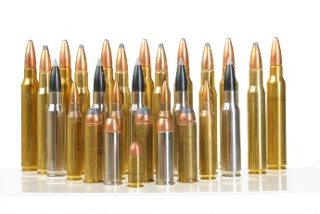60 Tables 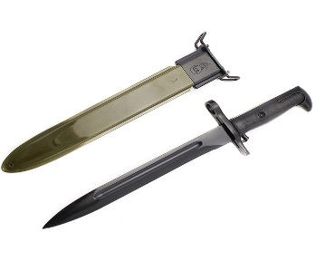  Location: I.B.E.W. hall, 48 Airport Rd. Concord, NH.  For more info. Go to www.nharmscollectors.org  Free admission for NHAC members and early admission  Half price admission for IBEW members with ID  Buy Sell Trade

