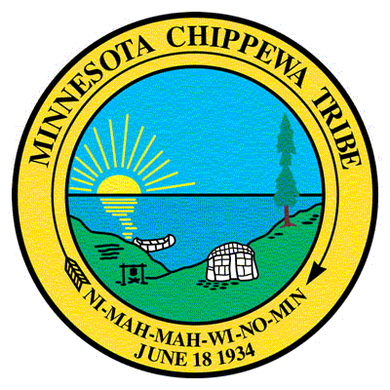

Johnson O’Malley Program
CERTIFICATION FORM

student information
Last Name: | First: |  |  | M.I.:
Date of Birth: | Enrollment Number: |  |  | Phone: ( )
School Attending: GRADE:
Student Mailing Address: | Student Physical Address: |  |  | Student Tribal Affiliation/Reservation:
_______________________________________  City: __________________________________  State: _________________ Zip: ____________ | ___________________________________  City: ______________________________  State: _______________ Zip: __________ |  |  | Tribe: ______________________________________  Reservation:_________________________________

Biological Mother’s Information
Last Name: | First: |  |  | M.I.: | Maiden:
- Indian  - Non-Indian | Date of Birth: |  |  | Place of Birth:
Mailing Address: | Physical Address: |  |  | Phone: ( )
City: | State: |  |  | Zip Code:
Reservation Enrolled: | Blood Quantum: |  |  | Enrollment Number:

Biological Father’s Information
Last Name: | First: |  |  | M.I.:
- Indian  - Non-Indian | Date of Birth: |  |  | Place of Birth:
Mailing Address: | Physical Address: |  |  | Phone: ( )
City: | State: |  |  | Zip Code:
Reservation Enrolled: | Blood Quantum: |  |  | Enrollment Number:

please check all boxes that apply to the custody/Residence of child:
- Natural Parent |  | - Other Family Member
- Legal Guardian |  | - Adoptive
- Foster |  | - Other (Explain)
Release of Information: I authorize the MCT and their designated person (s) to obtain/research my child’s tribal membership and/or blood quantum to determine JOM eligibility. In the event my child should transfer schools, I further authorize the MCT JOM Program to share this certification with the new school.
Parent Signature: |  |  | Date:

***Tribal Enrollment Official Use Only***
TRIBAL ENROLLMENT OFFICE/VERIFICATION OF INFORMATION (Please check appropriate box):

- The above named student meets the eligibility criteria as determined by the BIA and I hereby certify that this student is an enrolled member of an Indian tribe which is eligible for the special programs and services provided through the BIA to Indians because of their status as Indians.
- The above named student is not an enrolled member but is a descendent of the tribe and does possess a blood degree/blood quantum of .
- The above named student does not meet the eligibility criteria for the following reason (s):
- Birth Record/Birth Certificate is needed to verify enrollment/blood quantum.
- No information was found regarding enrollment/blood quantum for student/family.
Signature of Tribal Official: | Date:

