**"Raahauge's Hunting Club Presents"**

**Rattlesnake Avoidance Training**

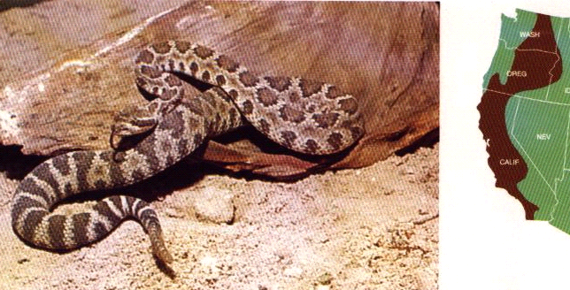

Rattlesnake Avoidance Training Includes:

. Individual dog training provided

. Dog training takes place in a natural controlled environment

. Rattlesnake scent, sound & sight awareness training

. Snake avoidance training with live muzzled snakes

**NEXT CLASS WILL BE HELD ON Saturday, October 2nd, 2021**

**(Book Early, Class Sizes Are Limited)**

**Call Raahauge’s Hunting Club @ 530-724-0552 to get an application sent to you.**

**Send the application back to us with a check ($80.00 per Dog /2 Dogs are only $75.00 ea.) to secure your appointment to: Raahauge's Hunting Club / P.O. Box 408 Dunnigan, Ca. 95937**

**(make your check payable to Raahauge’s )**

**Directions: 4.8 miles west of the I-5 fwy. at the Dunnigan exit #556**

**25835 County Rd. 8 (junction of rd. 8 and rd. 86)**

**\* We will call you when we receive your check to set up a time and day**

**\* Come 15 minutes prior to your appointment time**