P

P

Atch OSC

Umpkin



**Newsletter 2019**

Dear Parents,

Wow I really can’t believe how fast this is year is flying by. In Room 1, the children wanted to explore their cultures. It was fabulous how they worked hard and were proud to show off some of the things they do. Room 2 also had cultural experiences, winter and ground hog week. Room 3 had fun with winter, fruits, transportation and a talent show theme.

This month each room will be having their own Valentine parties. Each party will start around 3PM. If you would like to sign up for treats, there will be sign up sheets in each of the rooms.

As per requested from the children we will be planning a skating party. The tentative date will be February 28th, 2019 (as it is a no school day). **All** **Children** who want to participate must have skates with skate guards or skate bag, certified hockey helmet with cage, proper out door clothing such as water proof gloves, snow pants, winter jacket and toque. We will not except notes for your child to not wear a helmet as this is a huge safety precaution. Permission slips will be out shortly. We will also be tobogganing on march 1st2019.

We have launched a new website. Check us out at pumpkinpatchoutofschoolcare.ca

Do you have a home company or business? And No where to advertise? We can add your advertisement onto our newsletter, webpage and community Bulletin Board. Just ask us how?

**Hot Lunch Fundraisers:**

February 7th, 2019 = Taco in a bag

February 21st, 2019 = Chicken Wraps

**Preschool room Update**

We have submitted papers to the city and to our health officer. As soon as we get city approval, we will start taking registration.

Thank You

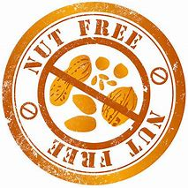Pumpkin Patch OSC

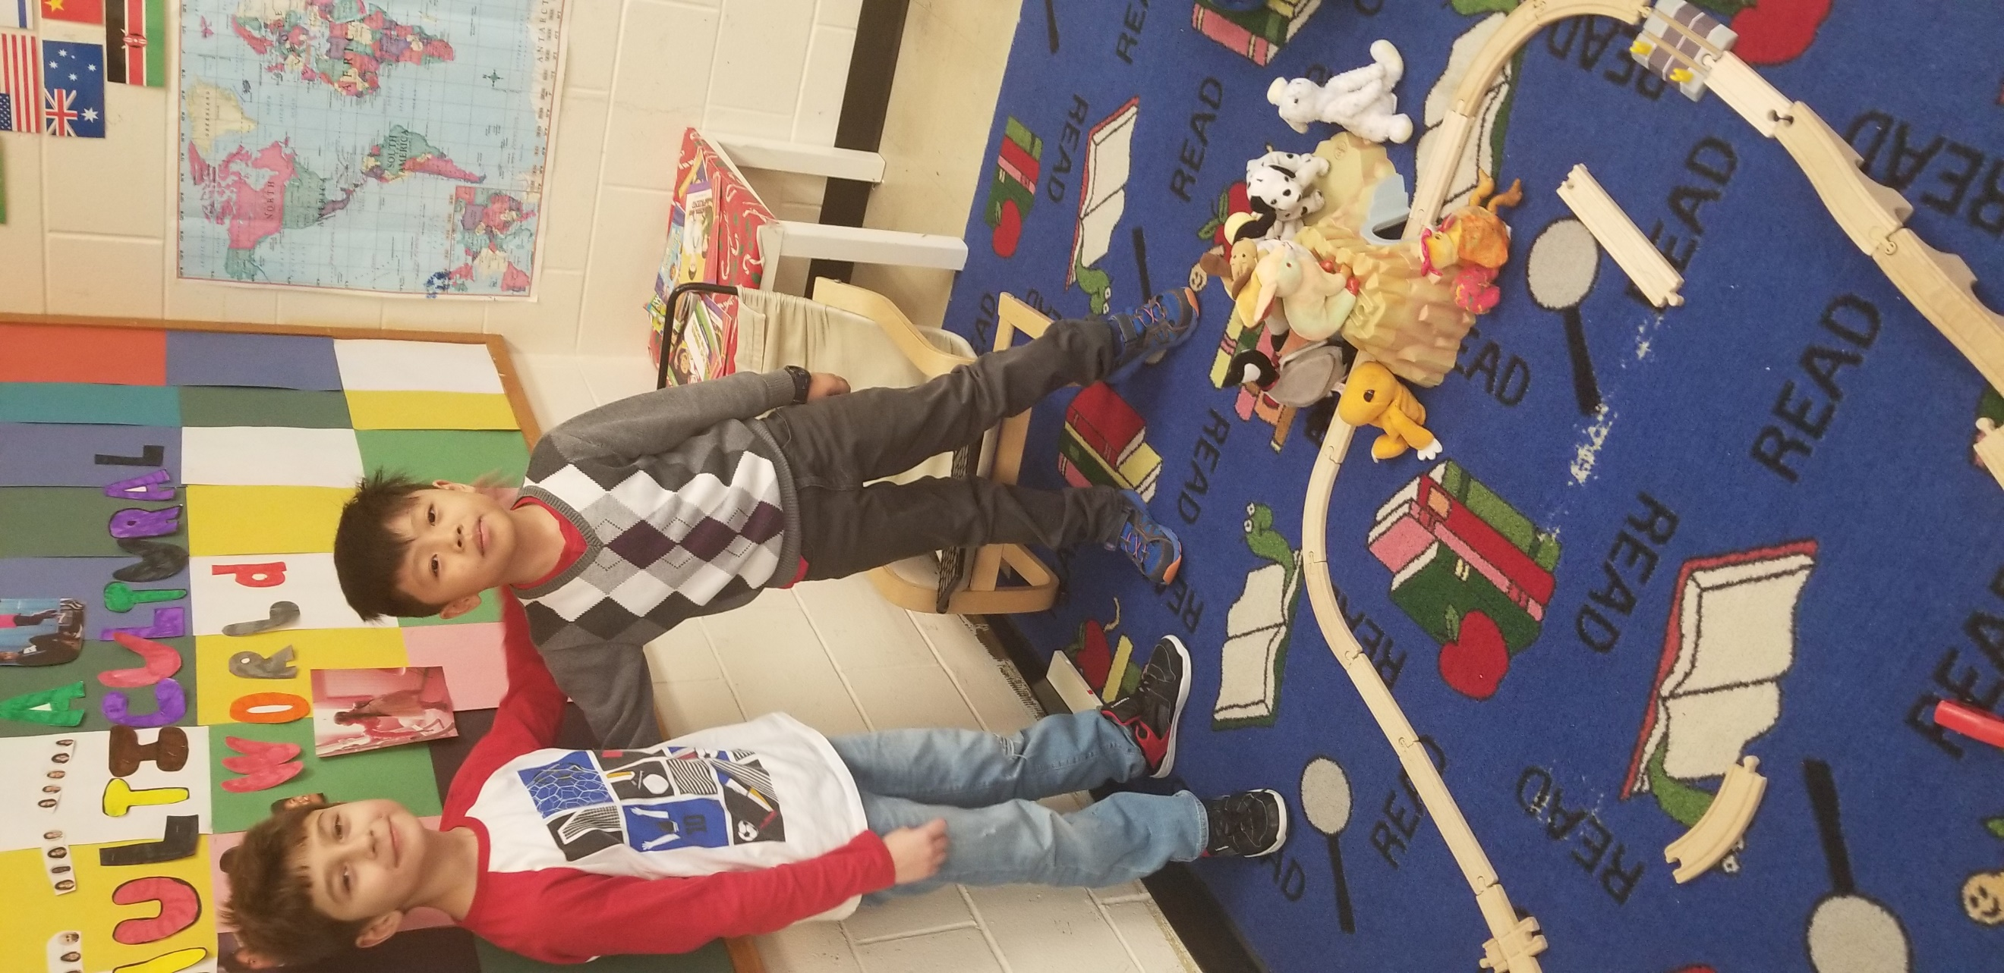

Important dates & Stat Holidays to remember

|  |  |
| --- | --- |
| January 1st, 2019 | New Years Day (Closed) |
| February 14th 2018 | Valentines Day |
| February 18th, 2019 | Family Day (Closed) |
| March 17th 2019 | St. Patty’s Day |
| April 19th, 2019 | Good Friday (Closed) |
| April 22nd, 2019 | Easter Monday (Closed) |
| May 20th, 2019 | Victoria Day (Closed) |
| May 12th 2019 | Mother’s Day |
| June 16th 2019 | Father’s Day |
| July 1st, 2019 | Canada Day (Closed) |
| August 5 2019 | Civic Holiday (Closed) |
| July 22nd-August 6th 2019 | Summer Closure |
| September 2nd 2019 | Labour Day (Closed) |
| October 14th 2019 | Thanks Giving (Closed) |
| October 31st 2019 | Halloween |
| November 11th, 2019 | Remembrance Day (Closed) |
| December 16th-19th, 2019 | Bake Sale |
| December 20th, 2019 | Turkey Lunch |
| December 20th, 2019 | Christmas Party |
| December 24th2019 | Christmas Eve |
| December 25th 2019 | Christmas Day (Closed) |
| December 26th 2019 | Boxing Day (Closed) |
| December 31st 2019 | New Years Eve (Open) |



February Birthdays

Eleanor 16

Sophie 18

Addison 13

Aiden 25

**E-transfer**: [pumpkinpatchosc@gmail.com](mailto:pumpkinpatchosc@gmail.com)

Password: pumpkinpatch

Center Phone Number: 780-807-3090

Center Email: [osc.st.angela@gmail.com](mailto:osc.st.angela@gmail.com)

Center Address: 13430-132A Street Edmonton Alberta T5L 1S3

Pumpkin Patch OSC Selfies

