Appendix A
Figure A1. Intensive Family Support Service (IFSS) Logic Model
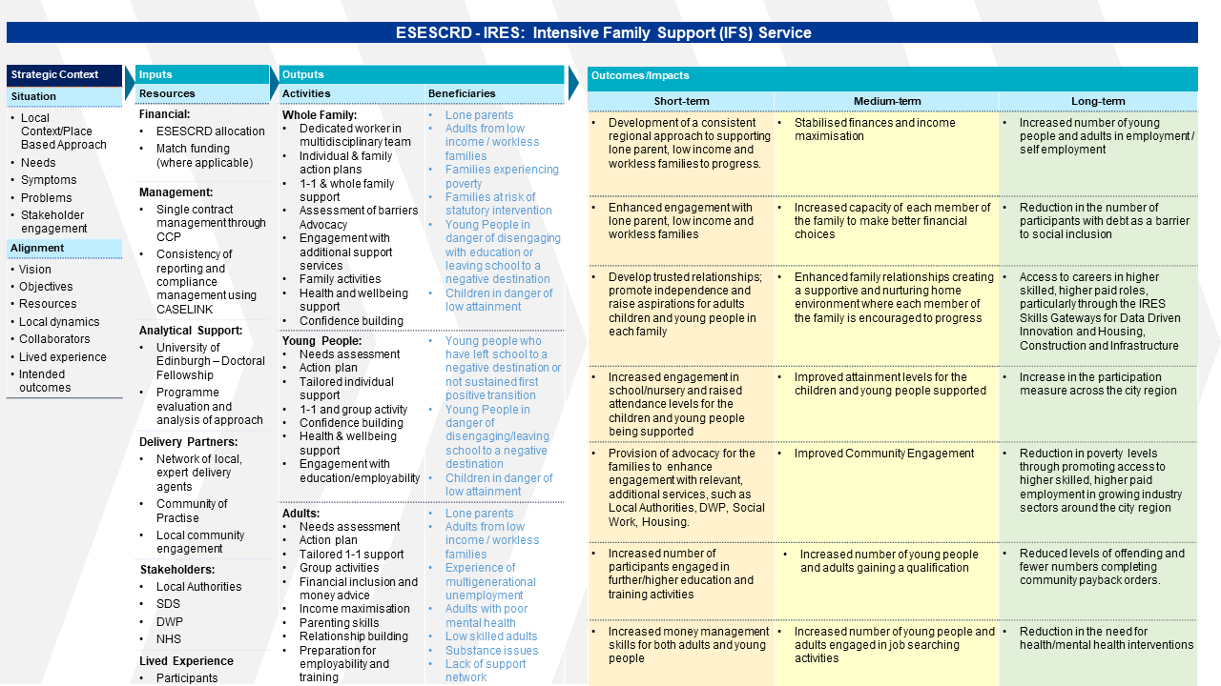

Figure A2. Family Action Plan from Maximise! Early Years (Edinburgh)
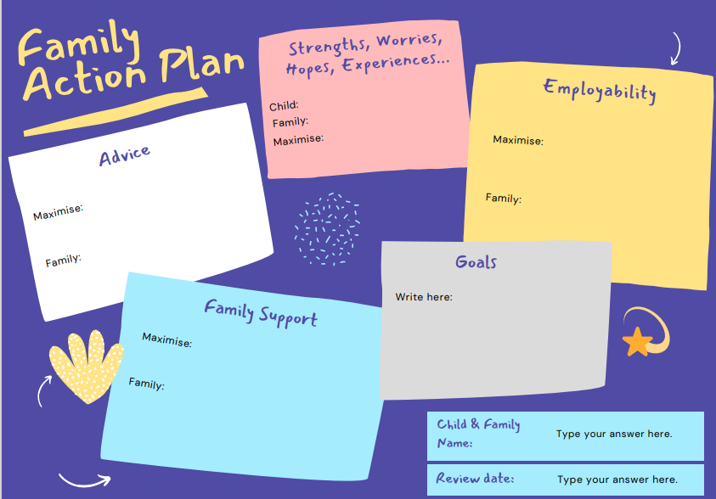

Figure A3. Fishbone Quality Improvement Tool from Making It Work for Families (Fife)
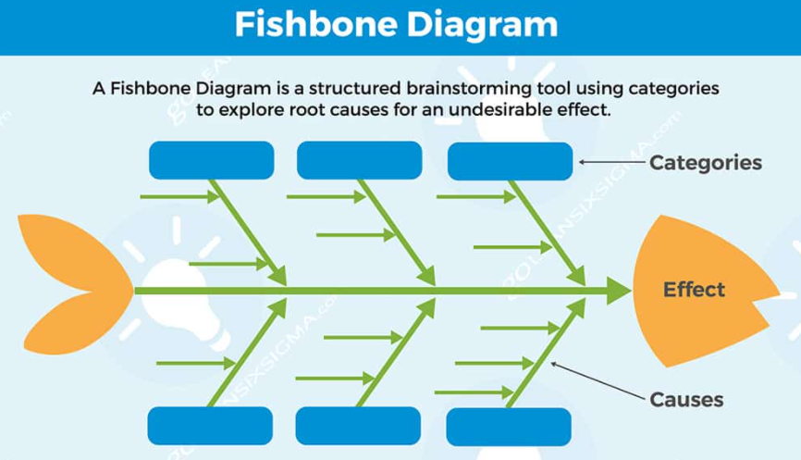
Figure A4. Example of Newsletters, Excerpt from Edinburgh Delivery Partner (Maximise! Early Years)
Page 1 Autumn 2021 Newsletter
Page 1 Winter 2021 Newsletter
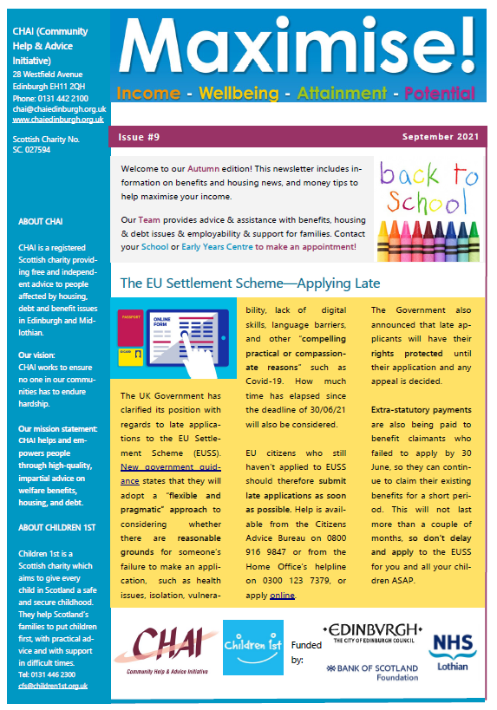
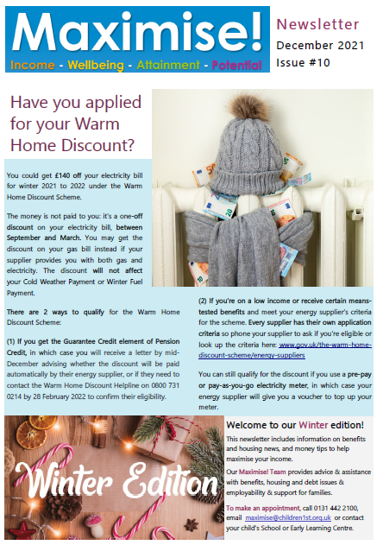

Appendix B
Table B1. Family Engagements
Local Authority | 2020 (Q2) | 2020 (Q3) | 2020 (Q4) | 2021 (Q1) | 2021 (Q2) | 2021 (Q3)
East Lothian | 5 | 19 | 24 | 26 | 29 | 36
Edinburgh | 0 | 17 | 19 | 25 | 29 | 29
Fife* | na | na | 18 | 21 | 23 | 30
Midlothian | 3 | 6 | 6 | 8 | 13 | 15
West Lothian* | na | na | 0 | 8 | 14 | 18
Scottish Borders* | na | na | 0 | 0 | 9 | 16
 |  |  |  |  | TOTAL | 144

Table B2. Adult Engagements
Local Authority | 2020 (Q2) | 2020 (Q3) | 2020 (Q4) | 2021 (Q1) | 2021 (Q2) | 2021 (Q3)
East Lothian | 7 | 23 | 28 | 30 | 33 | 35
Edinburgh | 0 | 0 | 34 | 29 | 39 | 39
Fife* | na | na | 8 | 22 | 28 | 34
Midlothian | 3 | 6 | 6 | 8 | 15 | 15
West Lothian* | na | na | 0 | 1 | 6 | 17
Scottish Borders* | na | na | 0 | 0 | 12 | 25
 |  |  |  |  | TOTAL | 165

Table B3 Young People Engagements
Local Authority | 2020 (Q2) | 2020 (Q3) | 2020 (Q4) | 2021 (Q1) | 2021 (Q2) | 2021 (Q3)
East Lothian | 7 | 35 | 49 | 53 | 59 | 78
Edinburgh | 0 | 0 | 59 | 51 | 63 | 63
Fife* | na | na | 21 | 28 | 32 | 36
Midlothian | 3 | 10 | 10 | 13 | 30 | 30
West Lothian* | na | na | 0 | 7 | 8 | 9
Scottish Borders* | na | na | 0 | 0 | 22 | 36
 |  |  |  |  | TOTAL | 252

Table B4. Completion of Target Engagements
Local Authority | Number of Engagements |  |  | Targets |  | % Completion
 | Families | Adults | Young People | Family  Targets | Individual  Targets | % Completion  Family | % Completion  Individual
East Lothian | 36 | 35 | 78 | 19 | 66 | 189% | 171%
Edinburgh | 29 | 39 | 63 | 27 | 90 | 107% | 113%
Fife | 30 | 34 | 36 | 20 | 69 | 150% | 101%
Midlothian | 15 | 15 | 30 | 16 | 45 | 94% | 100%
West Lothian | 18 | 17 | 9 | 24 | 76 | 75% | 34%
Scottish Borders | 16 | 25 | 36 | 10 | 35 | 160% | 174%
TOTALS | 144 | 165 | 252 | 116 | 381 | 124% | 109%

