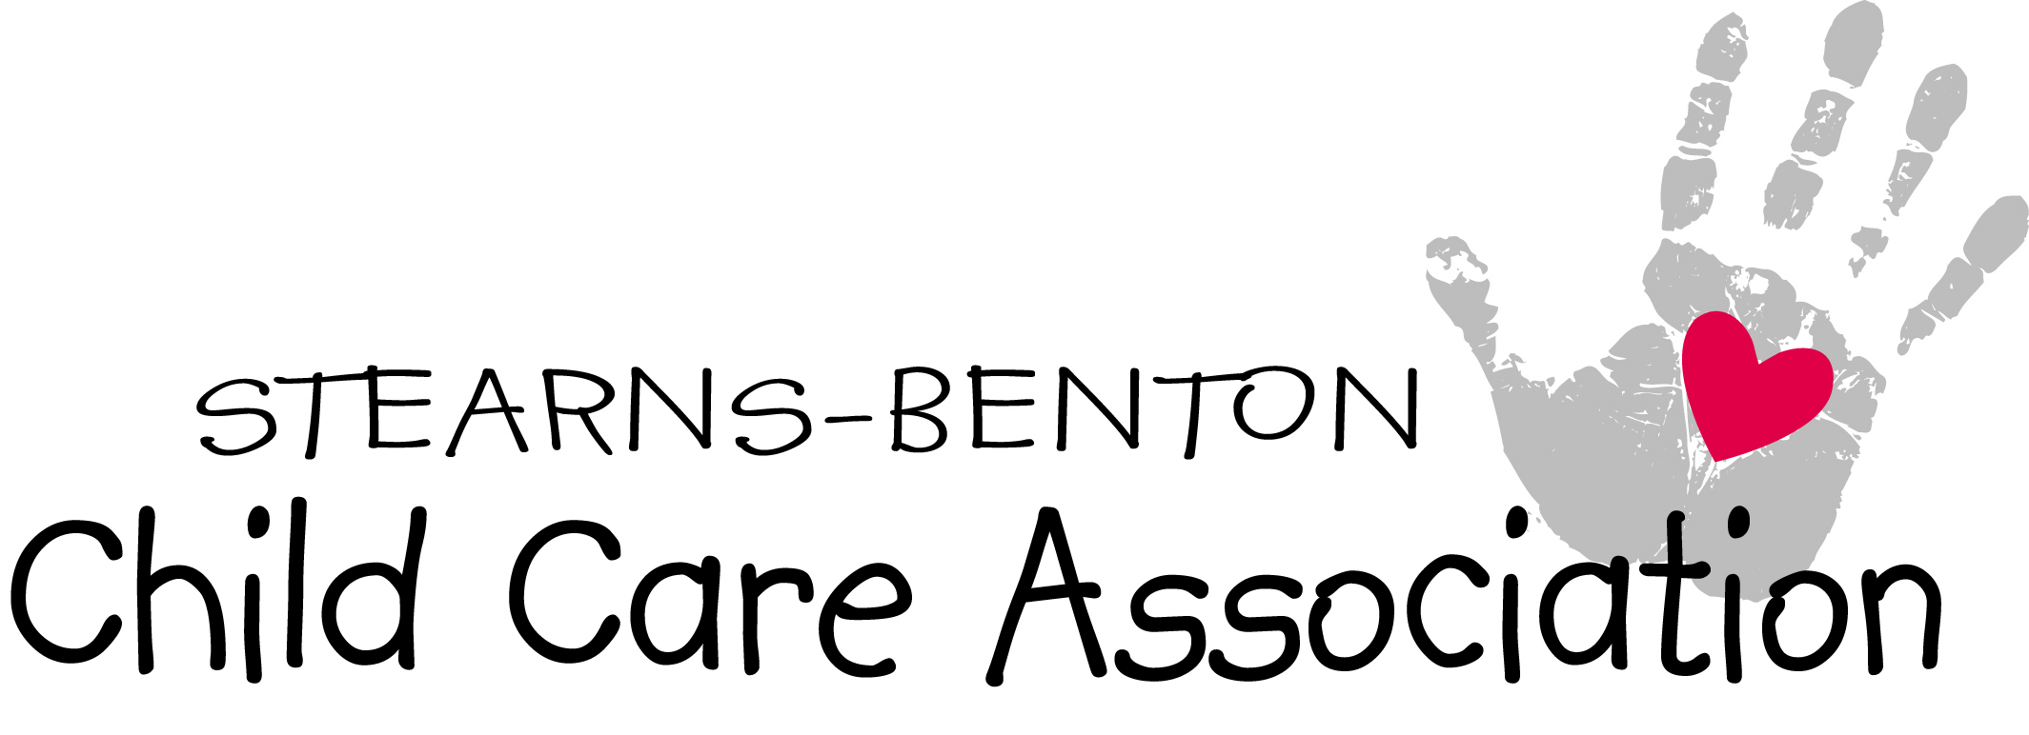
Welcome

Welcome to the Stearns-Benton Child Care Association, also
known as SBCCA. The Stearns-Benton Child Care Association was
established in November 1988. We continue to grow in membership
each year. This association is made up of Licensed Child Care
Providers, County Licensors, Food Program Representatives, and
other people who care about quality childcare. We also welcome
providers from Sherburne County.

The Stearns-Benton Child Care Association offers many
opportunities of learning, training, input, guidance, sharing,
friendship, fun events and an enjoyable atmosphere.

Our meetings are scheduled on the second Monday of each
month. Doors are opened at 6:00 pm for socializing, signing in, and
checking out materials from our lending library. This is followed by a
business meeting and a two-hour training that is DHS approved. We
are glad to have you as part of our providers’ network.

Facts about Membership

Welcome Table: As you enter our meetings you will see a welcome table. There is a lot
of information and fun tidbits for everyone. You will also find the attendance sheet, your
name tag and the think tank. Please stop by the welcome table before entering the
meeting.

Sign-in Sheet: The sign-in sheet is located on the welcome table prior to entering the
meeting room. Please mark the sheet; this is used as a record of attendance for trainings
taken so that you receive your certificate. If your contact information has changed please
make the changes on the attendance sheet.

Membership: Annual Membership is $45.00 per year from June 1- May 31. This covers
from June 1 of the current year through May 31 of the following year. Your membership
dues will entitle you to receive various trainings at the regular Monday night meetings
without any additional charge. Membership dues can be paid to the treasurer at any
meeting or can be mailed to our PO Box (address located at the bottom of this page). If
your membership is not paid by July’s meeting, your name will be taken off the mailing
list until dues are paid.

Guest: The first visit is free. If the meeting you attend is also a training course and you
want to receive a credited training certificate, training fees will apply.

Training: The training fee for non-members is $20.00 for the two hour training.

Name Tags: Preprinted nametags are located on the welcome table upon entering the
meeting room.

Think Tank: A suggestion box is available at the Welcome table for any comments or
suggestions you may have to better our Association. All suggestions and comments are
discussed at the Executive Board meeting and answered at the next meeting to the best of
our ability.

Board: The Executive Board consists of a President, Vice President, Secretary, Treasurer, Librarian, Historian, Liaison and Past President. Each position is explained in the by-Laws. The officers are elected in May of each year and take office in June and hold the office through May of the following year.
Board meetings for SBCCA are held quarterly. Board meetings are open to all members
with advance notification. This notification is needed to make sure there is enough space
and in case scheduling conflicts arise. Additional board meetings may be called as
needed.

The planned board meetings will be on a day that will be announced, the month at the
beginning of each quarter.

Lending Library: Our lending library is available to all members. The library consists of
books, magazines, video, CDs and audiotapes. The materials may be checked out for up
to two months. To check out books or miscellaneous items, please remove the index card
from the selected item(s) and place it in the card box and then sign and date the library
log book. When returning items, please write the date in the log book and replace the
index card before returning it to the Library.

Additional activities: Throughout the year other additional classes and activities may
be planned by the SBCCA board for both recreational and educational purposes.
Recreational activities such as picnics, dinners, field trips and parties may be planned in
addition to the ones on the training schedule.

2018/2019 Board Members:

President: Kelly Martini Historian: Charla Attarsaheli
Email: martini@clearwire.net Email: cmattar484@msn.com
Phone #: 356-9134 Phone#: 654-9799
Vice President: Katie Schwagel Librarian: JoAnne Disrud
Email: katieschwegel@hotmail.com Email: disrudj@yahoo.com Phone#: 240-0281 Phone#: 259-0028
Secretary: Alyssa Hedlund Liaison: Sandie Trossen
Email: alyssaconstance123@gmail.com Email: strossen101@q.com
Phone#: 219-9144 Phone#: 255-0235
Treasurer: Karen Budde
Email: mybuddy.kk@msn.com
Phone#: 684-4471

INVOLVEMENT OPPORTUNITIES:

In August, sign-up sheets are passed out for members to volunteer for the following
monthly meeting commitments. This sign-up sheet will be at the Welcome table for
additional sign ups throughout the year.

Refreshments: We ask members take a turn sharing a snack with the group (Examples:
bars, fruit, mints, pop, water, juice, etc.) These members are also in charge of set up,
clean up and trash removal if needed for that meeting.

Association members are encouraged to participate in one of the following Committees:

Provider Appreciation Dinner: We have a special dinner for providers to let them know they’re appreciated in the community. Friday night of Mother’s Day Weekend.

Christmas Party: Plan an evening where members can celebrate the joyful season.
Share time: We welcome you to bring a few project ideas to share with all members.
This could include a circle time activity, craft or curriculum enhancement.

Fundraising: There are several opportunities to participate in fundraising for the
SBCCA. We also support the Anna Marie’s Alliance and do fundraising for their needs. (Fundraising is done if funds run low in the account.)

Membership Committee: Welcoming new members and giving them Welcome packets, or other information.

Child Care Training
(Taken off the DHS website)

Pre-Service Training
Pre-service training requirements must be met prior to initial licensure and include several new
training topics in addition to training on Sudden Unexpected Infant Death, Abusive Head
Trauma, and other previously required topics.
This new approved pre-service supervision training, as well as child development and behavior
guidance training, will be developed by December 2013 and available by January 2014 in both
classroom and online formats. The date which the new training requirements will take effect is
July 1, 2014. Any new provider licensed on and after July 1, 2014, will have to meet the new
pre-service training requirements before a license is issued. Training completed between
January 1 and June 30, 2014 will meet the new pre-service training requirements.
The new requirements include:
• Six hours of approved training on supervising for safety that includes: supervision basics,
outdoor supervision, safety precautions related to equipment and materials, illness,
injuries, and disaster preparedness.
• Four hours of approved child development and behavior guidance training that includes
specific content information on understanding the functions of children’s behavior and
developmentally appropriate strategies for managing behaviorally challenging situations.
MNCPD-approved trainings in the primary core competency areas of “Child Growth and
Development” as well as “Interactions with Children” will meet the child development
and behavior guidance training requirement.
Child Care Aware training will be offered throughout the state so that individuals interested in
becoming licensed will only need to travel a reasonable distance for classroom training. To
promote accessibility, some training is available online through Eager to Learn.
A variety of pre-service training courses – both classroom and online - are available at the low
rate of $5 per training hour. Classes include:
• Sudden Unexpected Infant Death (SUID)
• Abusive Head Trauma (AHT)
• Supervising for Safety
• Child Development/Behavior Guidance

Annual In-Service Training
For currently licensed providers, the 2013 legislation increases annual training requirements for
license holders and each primary caregiver from 8 hours annually to 16 hours annually; requires
annual training on supervising for safety, as well as child growth and development and behavior
guidance; and increases the frequency of SUID, AHT, CPR, and First Aid training.
The date which the new training requirements will take effect is July 1, 2014. Licensed providers
and caregivers will have the following year to complete the increased annual in-service training
requirements. On July 1, 2015, county licensors will begin monitoring provider compliance with
the increased training requirements.
The required frequency of specific training topics, which will count toward the annual 16 hour
annual training requirement, is as follows:

• Supervising for safety –required annually
• First aid – required every two years
• CPR (cardiopulmonary resuscitation) – required every two years
• SUID (Sudden Unexplained Infant Death) – required annually with a video option
allowed in the alternate year
• Abusive Head Trauma (AHT) – required annually
• Child passenger restraint systems – required every five years for those who transport
children
• Child growth and development and behavior guidance – required annually

Additional ongoing training subjects to meet the annual 16 hour training requirement must be
selected from the following options:
• Learning environment and curriculum
• Assessment and planning for children’s individual needs
• Interactions with children
• Families and communities
• Health, safety and nutrition
• Program planning and evaluation
• Cultural dynamics and /or disabilities training
Similar to pre-service training, a variety of classroom and online courses are available for $5 per
training hour for annual in-service training. Classes include:
• Sudden Unexpected Infant Death (SUID)
• Abusive Head Trauma (AHT)
• Supervising for Safety

Other approved sources:
American Red Cross (1 year certification)
www.childcarechoices.net
Technical Colleges
www.midwestchildcare.com
Community Education
www.door15.com (St Cloud Technical College)
www.mnchildcare.org
Food Program Conferences
www.mnstreams.org
Early Childhood Education
www.redleafinstitute.org
www.mneaeyc.org
www.mccpin.org

STEARNS-BENTON CHILD CARE ASSOCIATION MEMBERSHIP FORM
WELCOME to the Stearns-Benton Child Care Association!!
Membership Information
Name: ______________________________________________Email: ____________________________
Business Name: ___________________________________Phone # _____________________________
Address: ________________________________________City:_________________ Zip: ____________
County: ______________________Year Licensed: ________________ Birthday: ____________________
Photo Permission DEVELOP# _________________
I, __________________________________, herby give permission for Stearns-Benton Child Care Association to take pictures of myself and to use these pictures for marketing and on their website. I agree to hold Stearns-Benton Child Care Association harmless from any liability that may arise from the use of these phots.
Committees
As a member of the SBCCA, I would like to become involved by volunteering for the following committees:
_____ Social Committee (planning social outings and field trips for SBCCA members)
_____ Fundraising Committee (organizing fundraisers for SBCCA)
_____ Holiday Committee (planning the annual holiday party)
_____ Provider of the Year Committee (responsible for recognizing the provider of the year & nominees)
_____ Membership Committee (help with welcoming the new members and giving them information papers about the association)
Membership Dues
Membership dues are $45.00 per year (June 1- May 31)
Please mail payment to “SBCCA” or contact Treasurer: Karen Budde
Thank you for your membership!

If you have questions or comments please contact:
SBCCA President: Kelly Martini 320.493-9987
SBCCA Vice President: Katie Schwagel 248-4741

Website www.sbccaofmn.net Email: sbccaofmn@gmail.com Address: PO Box 7721 St Cloud, MN 56302

