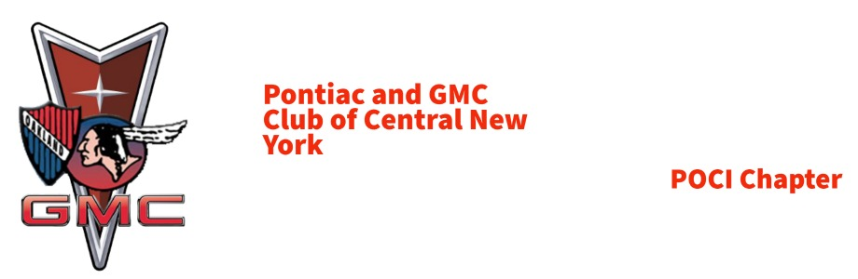

Pontiac GMC Club of Central New York Officers:

President: Art Johnston

Vice President: George Rink

Secretary: Heath Thomas

Treasurer: Tim Nichols

Web Editor: Chris Lorence

Activities: Albert Finocchiaro

Newsletter Editor: Lauri DeSalvia

February/March 2024 Newsletter

The President’s Message

ART’S EXHAUST Feb 2024
Our Next Meeting is at Flows RT 31 Canastota NY on Sunday March 10,2024 at 1PM.
Topics
2024 Bill Rapp Show
Pineview Run Track Day
Syracuse Nationals
Website, Facebook Updates
Member Topics
We have one of the early shows coming up, The Oneida Community Mansion House Car Show Saturday June 1,2024. This show has Two classes for Pontiacs Only, 1926-1980, and 1981-1999, plus a Camaro, Trans Am, Firebird Class through 1999.
We need to support shows that support Pontiacs
We also need to support The Cavalcade of Cars at the NYS Fairgrounds March 23 and 24, 2024. We have club members that work this show and the Auburn Auto Group is a Sponsor.
I want to Thank Joe & Jennette Olmsted for stepping up to run the 39th Pontiac & GMC Super Show. You are the BEST!!
Long-time Club Member Bill Ward passed away January 31,2024. Bill was a member you could always count on. He and his wife Marcia attended every meeting, event and with Guy Zipp made many Holiday parties extra fun with their gift selections. God Bless You.
Art

Minutes of our Last meeting

Pontiac GMC Club of Central New York
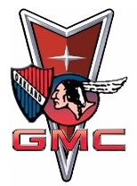
Officers
President: Art Johnston; Vice President: George Rink;
Secretary: Heath Thomas; Treasurer: Tim Nichols
Web Editor: Chris Lorence; Activities: Albert Finocchiaro

Date: 02-11-2024

Location: Flo’s Diner, Route 31, Canastota NY

Members in Attendance: Art Johnston, Lauri DeSalvia, Tim & Estre Nichols, Joe & Jennette Olmstead, George Rink, Albert
Finocchiaro, Chris Wheeler, Connie & Donald DeGroat, Heath & Melissa Thomas, Bernie & Cheryl Tufts.

New Members: Scott Heiland, 1966 Catalina Convertible

Guests: None

Lunch followed by Meeting called to order at : 1:45 pm
Topics of Discussion (New Business):

1. PRESIDENT REPORT:
a. We mourn the passing of long-time club member William “Bill” Ward. Bill passed away January 31, 2024. We pass our
condolences to Marcia and cherish the great memories we had with Bill. Chapter members attended Bill’s services and
funeral on 2/10/2024.
i. A “Celebration of Life” will be held on 4/27/2024 at the American Legion in Williamstown, NY from 3-6 pm.
There will be a catered dinner.
ii. The following is a link to Bill’s obituary
https://www.watsontraubfuneralhome.com/obituary/WilliamBill-Ward

b. 2024 Super Show
i. New Show Chairs. Joe & Jennette Olmstead have graciously volunteered to shoulder the burden of being our
car show organizers.

• A TREMENDOUS THANKS goes to Bob Conniff for the many years he has been our Show Chairman!!
ii. There will be a few changes to our show classes. If you have any ideas, please pass them on to Joe & Jennette.
iii. We will be ordering T-shirts. They will be in Black or White and will have the “Gone But Not Forgotten”
logo. They will be available for purchase at the show.
iv. 2024 Show Flyer is READY for distribution. It will be sent separately. Please print and distribute WHERE
EVER you go!

v. PLEASE START COLLECTING DOOR PRIZES!!!
c. Chapter History. Art is still working to gather chapter history information and our original charter. If you have any info
on the origins of our chapter or know anyone that does or if anyone has any of our original paperwork, PLEASE let Art
know.
d. Web Site. Chris Lorence is our new Web Editor. He is migrating our chapter info from the old domain to our new one.
He plans to add info on our chapter history, our charter, and some pics of chapter cars to it. We are still in discussion as
to what else to post on our website. Do YOU want your car pics on the site? Please submit to me 1 or 2 pictures along
with any info you’d like to say about your car. We’ll let you know when the website is online and ready for action.
e. FaceBook page. Heath & Lauri will continue to maintain/update our chapter Face Book page.
f. Thanks to Heath & Melissa Thomas for hosting our Chapter Christmas Party!!!!! We had a wonderful time and they
have a beautiful house.
g. Syracuse Nationals.
i. Volunteers needed for the Friday morning registration tent
ii. TBD if volunteers will man the gates
iii. Thanks to the 2023 volunteers for their time and hard work at last year’s show

2. VICE PRESIDENT REPORT: Nothing to Report

3. NEWSLETTER EDITOR REPORT: Thanks to Chris Lorence for taking over the Web Site!

4. TREASURER REPORT
a. As of 1/1/2024, the chapter has $955.00 in our account with no outstanding bills.

b. PLEASE PAY YOUR 2024 DUES!!!!!!!

c. 50/50 made a total of $50. Lauri DeSalvia won the $25.

5. EVENTS REPORT provided by Albert.
a. Possible Garage Stops.
i. Ben Gregory’s Panther Lake Restoration
ii. Morrisville Ford and Morrisville University
iii. Rochester/Fairport private collections
b. AACA/POCI Spring Run. Plan for April/May trip to the Nicola Bulgari auto collection in Allentown, PA. The
collection contains 200+ very unique cars. Bulgari has a little of everything but like his Buicks. This will be a bus trip.
We need at least 100 participants for this special event to occur. More details to follow.

Old Business:
1. Albert asked if people would be interested in buying patches that could be attached to hats, sweatshirts or
jackets.
2. 2024 dues were due 1/1/2024. Please send/submit your 2024 dues to Tim.
Activities & Events:
1. 3/1-3/3. Hamburg Cavalcade of Cars. Hamburg Fairgrounds. Cavalcadeofcars.com
2. 3/23-3/24 Syracuse Cavalcade of Cars. NYS Syracuse Fairgrounds, Center of Progress Bldg. Cavalcadeofcars.com
3. 4/27 – 10/5. CNY CARS & COFFEE in Marcellus Park. Every Saturday, 8:30-10:30 am at the Creek Hollow Parking Lot, Platt
Road, Marcellus, NY 13108.
4. 4/29 – 10/7. CNY CARS & CONES at Skan-Ellus Drive In. Every Monday, 4:30-7:30 pm at the Skan-Ellus Drive In, Corner Rt 20
5. 6/1. 9am-4pm Oneida Mansion House Car Show. $15 pre/$20 day of registration fee.
6. 8/7. 11am-3pm. Gathering of Orphan Vehicles. Lewis Park, Minoa

Meeting Adjourned: 3:00ish

Next Meeting: Sunday, March 10, 2024 at Flo’s Diner. Lunch at 1200, meeting to start @ 1:00 pm

Items of Interest

From: Paul Bergstrom / POCI <pociworldhq@aol.com>
Sent: Monday, February 26, 2024 2:50 PM
To: James Patterson <antiquecarparts@msn.com>; ajjohnston@twcny.rr.com; raygto@aol.com; mr69cat@aol.com
Subject: Re: Smoke Signals magazine collection - upstate NY

sorry her correct email address is lcroft1@ftny.rr.com

or, you can leave a phone message 607-797-9066

Paul Bergstrom
POCI Club Office Manager
Email: pociworldhq@aol.com
Phone: (763) 479-2111
9am-5pm Mon-Fri CST
Fax: (763) 479-3571
POCI website
POCI Facebook Page
Our 52nd Annual Convention will be held in Springdale, Arkansas July 15-20, 2024
Pontiac-Oakland Club International | P.O. Box 421 | Long Lake, MN 55356
"Keeping the Pontiac Legacy Alive"

On Monday, February 26, 2024 at 01:28:57 PM CST, Paul Bergstrom / POCI <pociworldhq@aol.com> wrote:

FYI, POCI widow has a vast collection of SMOKE SIGNALS magazines, in upstate NY if anyone is interested

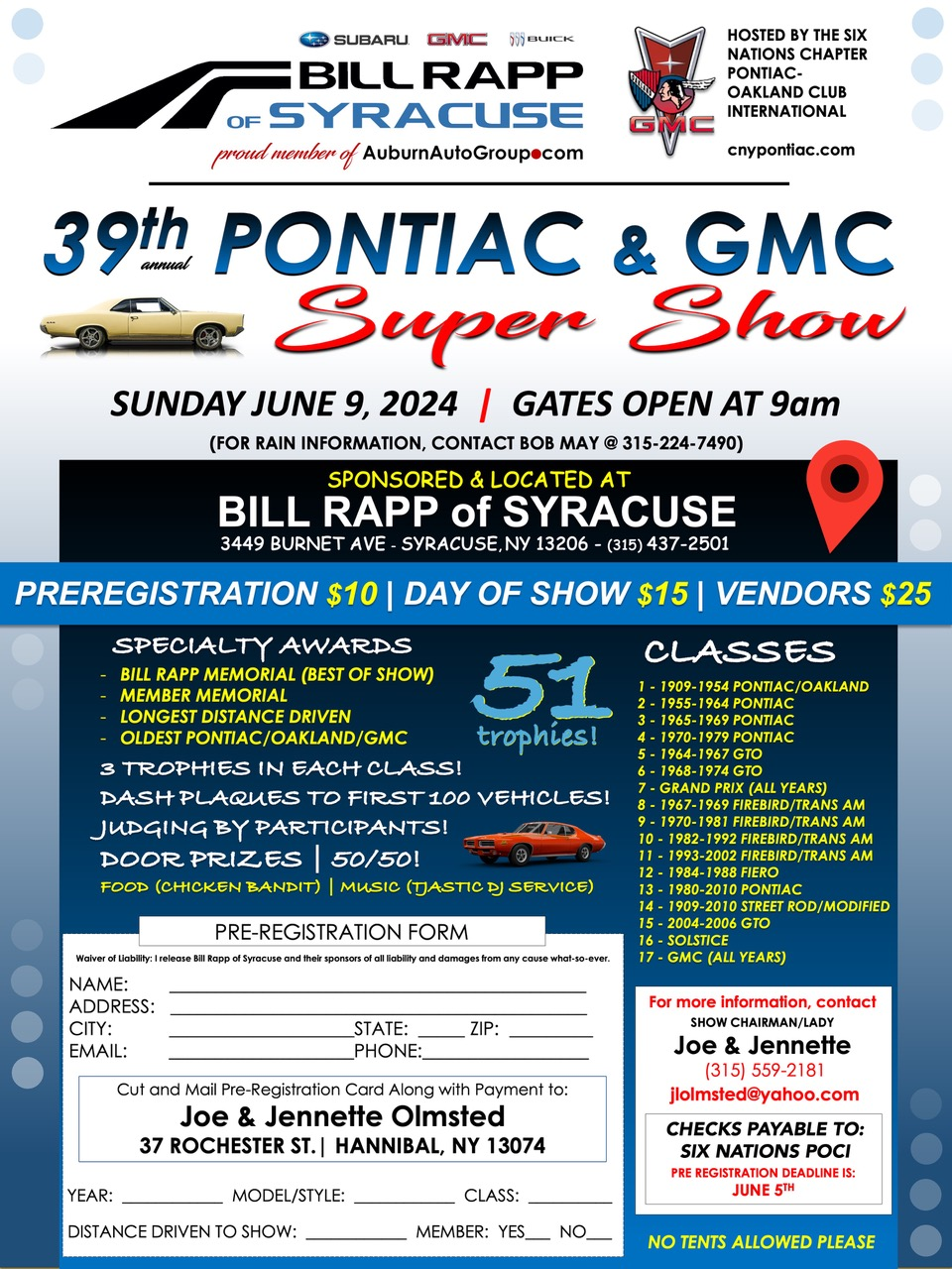
From: Heath Thomas <heeters78@comcast.net>
Subject: New CNY Pontiac GMC web site
Date: Feb 25, 2024 at 2:58 AM
Hello Everyone,

Chris has done a great job with our new website. It is up and running and can be found at www.cnypontiac.com

Take a look at it. If you have any recommendations, please let me know. The website is still evolving. Chris will be adding an EVENTS page soon. And pics, pics, pics.

Cheers, Heath

From our website:

Name: William Liccardi
Email :Wliccardi69@gmsil.com
Message: I have a 1999 Pontiac Bonneville SSE in great shape needs work because I could use for a parts car. I didn’t want to have it crushed. Let me know if somebody’s looking for one gold body leather aircrews tell it’s got everything runs great. Just needs suspension work.

