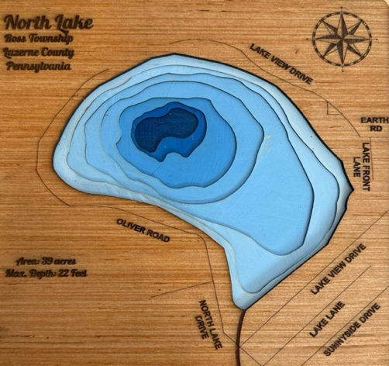
North Lake Improvement Association

2026 Membership Form

Name:

Preferred Phone:

Email Address:

Mailing Address:

North Lake Address (if different than permanent address):

Below is the invoice for the NLIA membership dues for the 2026 season as well as a donation request. Please follow one of the two options below to complete payment:
1. Online Option – Please go to www.Nlake.org and click the Join/Donate section in the bar at top of the website page. Complete the registration information requested and make payment using a credit/debit card or bank account. Note: Our transaction partner (Zeffy) has an optional and voluntary transaction fee that is defaulted to an amount, you can select “other” from the drop-down menu and enter “0” or an amount you would like to include. This is not required and NLIA is not obligated to pay any fees.

2. Mail Option – Download, complete and print form and mail it with your check to:
NORTH LAKE IMPROVEMENT ASSN., INC.
P.O. BOX 204
SWEET VALLEY, PA 18656

NLIA 2026 Dues: ($100 per Household) $100.00

Donation

TOTAL ENCLOSED $

The North Lake Improvement Association, Inc. is an IRC Section 501(c)(3) organization and donations are tax deductible under Section 170 of the Internal Revenue Code.

