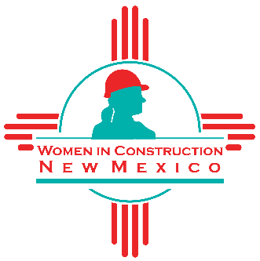

Mission Statement

“The purpose for which the association is organized is to promote common interests of its members through membership, networking, community outreach, training, and to advance and maintain an enlightened understanding of women in the construction industry.”

