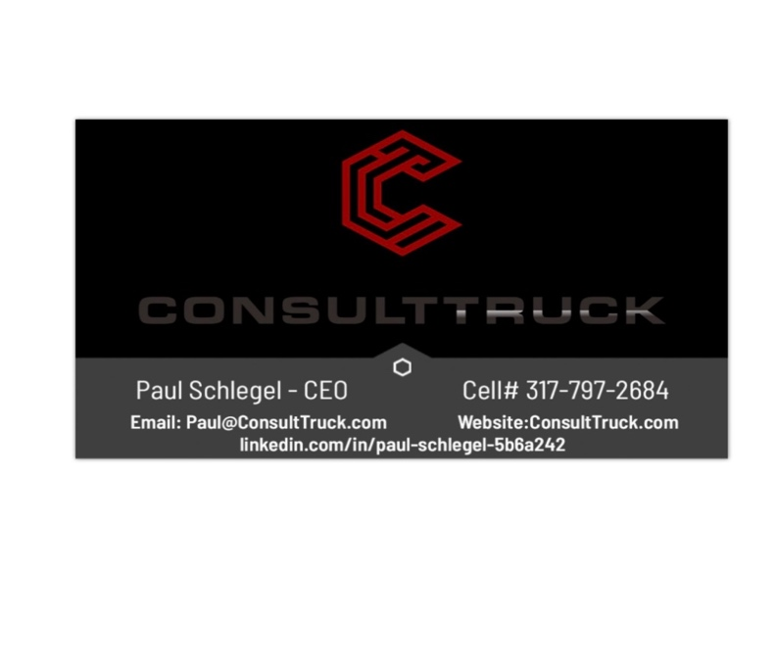
Transportation Specialty or Specialties:
Van TL, Refrigerated, Flatbed, IT, Operations, Brokerage, Team Expedited, Driver Training,
Recruiting, Human Resources, Loss Prevention, Dedicated Services,
Regulatory Compliance, Technology, Autonomous Operations, Labor law,
Venture Capital, M&A.

# of years in Transportation
38 Years Transportation experience with over 25 years of experience in Director through Executive level positions.
Organizations represented
Schneider National, Steven Transport, Roadrunner Transportation, EBB Investment Bank, Starsky Robotics, CloudTrucks LLC & ConsultTruck LLC.
Transportation roles over past 20 Years
CEO, VP of Safety and Compliance, Senior VP Operations, Executive VP of Operations, VP of Network Development, VP Operations and Administration, Director of MW Regional, Director of Team Expedited, Director of Regional Operations, Terminal Operations Center Manager,

Unique Skills or experience in related industries
FMCSA Regulations, Labor Law, Human Resource management, Mobile Phone application development
Autonomous Trucks, Equipment Purchasing/Specifications, AB5, Contractor relations and regulations, ELD’s, Food Safety Modernization Act, DOT audits and DataQ, Transportation Management Systems
Safety Management Systems, Legal and Compliant Driver On-Boarding, DOT/MC Compliance Regulations
Insurance, Liability and Loss Prevention, Claims Management, Brokerage
Private Equity and Venture Capital investments

