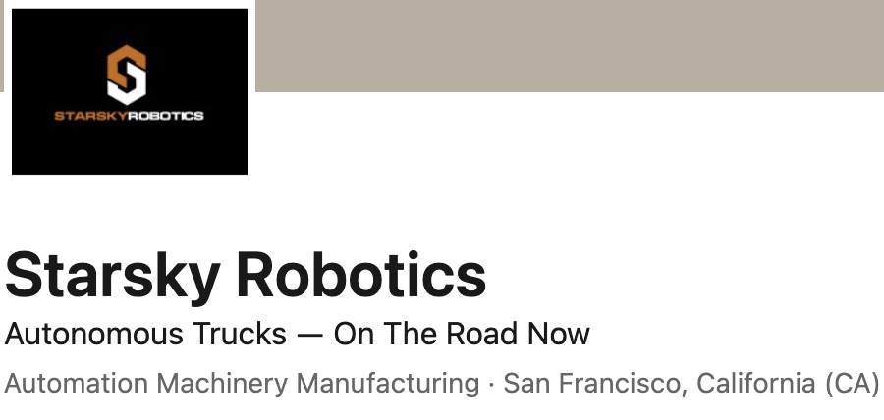

* Recruited to Starsky to build and operate a Trucking company to support Autonomous Vehicle development
* Developed aspirational business plan and presented to the Board of Directors
* Served as a Board of Director member for the entire time working at Starsky
* Set the budget, hired the CFO and established monthly growth projections
* Established an entire operational team to handle all aspects of the new company
  + Operations and Dispatch
  + Customer Service
  + Safety and Compliance
  + Recruiting
* Set-up favorable lease terms on 50 trucks through TEL Leasing, Penske Leasing and Ryder
* Established Leasing deals for 60 trailers through Quality Leasing and TEL Leasing
* Develop hiring criteria and Compliance guidelines for drug testing, CSA and Inspections
* Created Training plan and materials to qualify drivers to become Autonomous Vehicle Test drivers
* Put together Driver handbook and all operational safety procedures
* Negotiated Insurance policies and monitored all potential liability
* Built an efficient trucking company of 50 qualified drivers in less than 9 months
* Qualified 10 drivers to be safety drivers for Autonomous development