The Role: Trainee Account Executive
Halfspace are looking for an ambitious person interested in working in the sports industry with a focus on digital and data.

Start Date: As soon as possible
Job Type: Full Time
Renumeration: Entry Level
Reporting To: Account Director
Location: Flexible working, London office minimum 2 days a week
Applicants contact information: rory@halfspace.co.uk

About Halfspace:
Halfspace is a data driven full-service Marketing and Technology Group for the sports, media, gaming and entertainment industries, based in London. Our USP is the combination of advanced data technology solutions with creative and digital marketing services to deliver clients an end-to-end solution.
We believe passionately that harnessing detailed insights on fanbases through market leading data technology can fundamentally change the commercial trajectories of our clients.
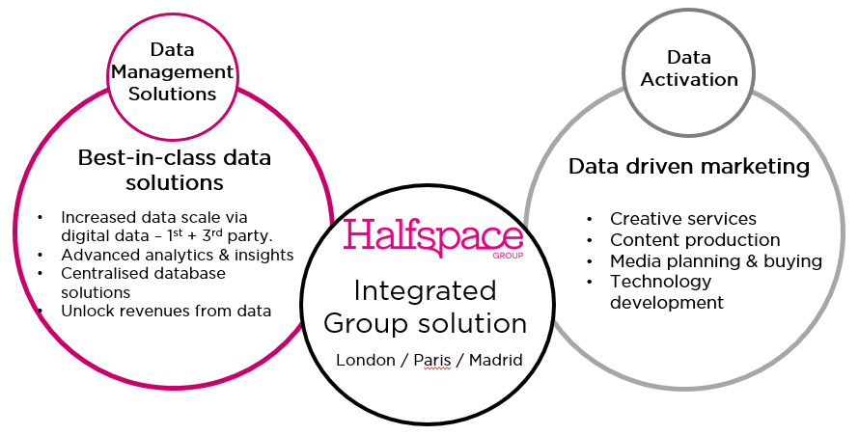

Using data technology solutions and analytics, we scale and enhance 1st party data strategies for our clients and uncover deep learnings around their audiences and fans using thousands of 3rd party data sources. We work with businesses such as football clubs, rights holders & federations, brands, sports technology platforms, health & fitness apps, and large-scale media publishers to illustrate the breadth of our client base.
Our solutions are specifically designed to scale the data collection capabilities of our clients, and in addition leverage the data insights to drive growth to their fan base and commercial revenues. We deliver this growth through the agency side of Halfspace - specialist digital marketing services – across creative, content production, media planning and technology development capabilities.

About the Role:
The role will be to work within the Halfspace client account team to support the team members in research and reporting across exiting and new clients.
The diversity of the client base will provide a broad breadth of experience and application to help an ambitious individual expand their capabilities.
The role is an exciting opportunity for an individual looking to enter the sports & digital media industries and the role will provide experience in a fast growth business.
An ability to operate flexibly in a dynamic, fast paced and fun environment is essential. The role will provide a superb foundation for a future career in this industry.

Key Responsibilities & Objectives: -
- Assist in maintaining relationships with clients, ensuring their needs are understood and met, supporting the delivery of first-class client services across the business
- Attend client meetings, prepare meeting notes, and follow up on action points
- Obtaining and collating reporting across social media, websites and data platforms as directed by the Account Director
- Working with the team to develop presentations outlining the results of data analysis and research
- Researching industry trends, competition, opportunities
- Support in other necessary areas as directed by the Account Director and Account Manager across client work
Requirements of the Candidate: -
- The candidate will have a keen interest in sport and digital marketing
- The role requires a developing interest in marketing and data
- Strong communication skills are a must
- Comfortable working to deadlines
- Training will be provided across technology, Excel and PowerPoint.
- The candidate is expected to be familiar the major social media platforms
- An interest in media, understanding of consumer and content trends, and having interests in sport and music is certainly an advantage!
- Above all we need a highly self-motivated, organised individual who loves to learn, likes being part of a hardworking team, and likes to have fun!
Diversity & Inclusion
Halfspace has an underlying belief that our services should reflect the society in which we live. Be that Age, Disability, Education, Ethnicity, Gender, Gender identity, National Origin, Religion or Sexual Orientation.
Simply, we believe that Inclusion and Diversity makes for a more stimulating and inspiring working environment, where people are treated with respect and can be comfortable being themselves. Embracing these different approaches and thinking helps deliver tangible and positive results for our clients’ businesses.

Benefits
- 25 days holiday
- Company Bonus Scheme
- Employer Pension Contribution
- Flexible working/working from home
- Laptop
- Social Events

