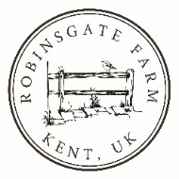
Declaration of Conformity

Name: FR201 Green & Grey
Description: Double oven glove

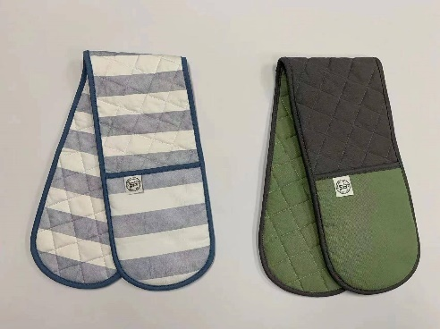

Manufacturer: Grayfish Ltd
Registered Address: 71-75 Shelton Street, Covent Garden, London WC2H 9JQ

This declaration of conformity is issued under the sole responsibility of the manufacturer.
This product has been shown to conform to Module B of UK 2019 SI696 schedule 35 regulation 38, Module B of the PPE Regulation (EU) 2016/425 and regulation 2016/425 on personal protective equipment as brought into UK law and amended, and as a Category II product through testing to the following standards: EN 407:2020 and BS EN ISO 21420:2020. Samples tested to Contact Heat Level 2 (250°C) against ISO 12127-1:2015.
The product is the same as the sample PPE which is subject of UKCA certificate number 524347 and CE certificate number SH01409, tested and certified by:

UK Approved Body: BTTG
Address: Unit 6 Wheel Forge Way, Trafford Park, Manchester M17 1EH.
Approved Body Number: 0338
Test Report Numbers: E-028515/A and E-028515/B

EU Notified Body: Shirley Technologies (Europe) Ltd
Address: Sky Business Centre, Office 13, Unit 21, Clonshaugh Business Park, Dublin 17, Ireland.
Notified body numbers: 2895

Grayfish Ltd holds technical documentation for specifications upon which conformity is declared.

Name: | Maria Gray | For and on behalf of: | Grayfish Ltd
Position: | Company Director | Date: | 15 August 2023
Signature: | Maria Gray

