TYPES OF PROJECTS AND EQUIPMENT

The projects vary according to the skills of your group and to the host church setting.

JAM makes a commitment to inform the team of the projects your group will undertake prior to arrival.

In the past, work camp projects have included:

- Handicap Ramps
- Minor building repairs
- Conducting Vacation Bible School
- Framing walls etc. for housing projects
- Roof repair
- Floor replacement
- Interior/exterior painting (houses/churches)
- Working in clothing banks, senior citizen centers, food pantries, etc…

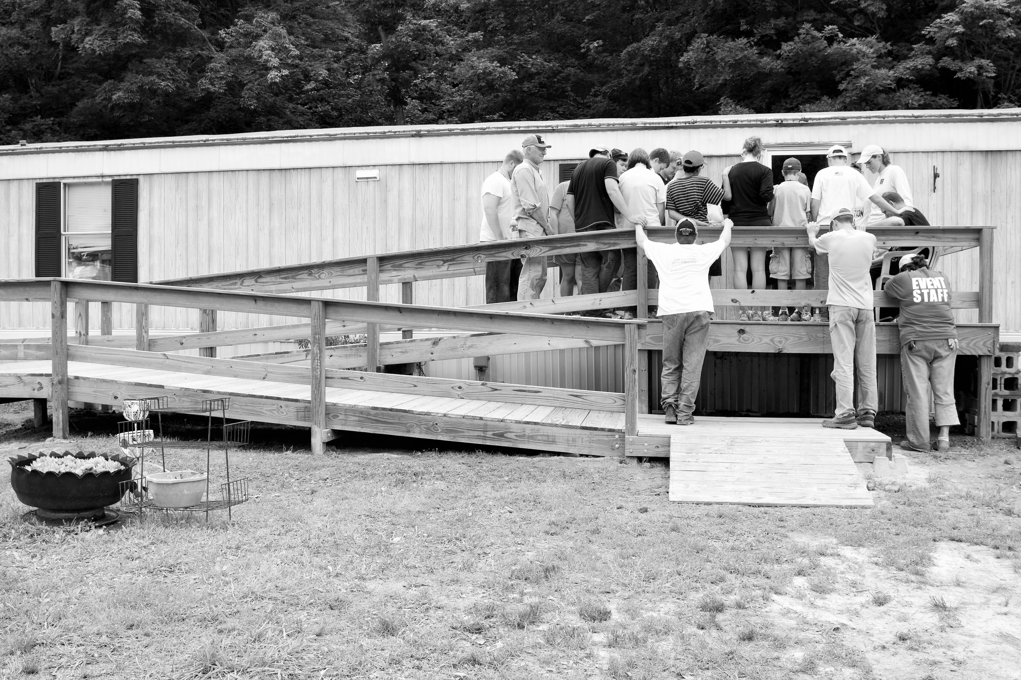

GUIDELINES
SUPERVISION You need one (1) adult leader for every five (5) Senior High youth, and one (1) adult leader for each four (4) Junior High youth. Leaders must accompany the teams to work sites and should be at least 21 years old.

TRANSPORTATION…You will need to provide your own transportation from the time of leaving your community until your return.

DELIVERY OF MATERIALS Materials and supplies needed for your projects will be ordered by JAM from the lumber store closest to your location. Most materials will be delivered to your site by the first day of work.

MEALS…Groups will be responsible for all meals. The host church will provide kitchen facilities.
Sack lunches should be prepared to take to work sites.

HOUSING…Area Congregations will provide sleeping/eating/restroom areas. You are asked to keep your area clean and neat. Upon departure, please leave the church as clean as or cleaner than when you arrived.

SHOWERS…Shower facilities will be provided. An adult must be on the shower facility premises when in use. The adult is responsible for the inspection of the facility and all areas accessed by the group each time the facility is used.

CHURCH/WORSHIP SERVICES…When appropriate you will be invited to participate in Worship and Sunday school classes at your host church and at other scheduled events if feasible.

ALCOHOL, DRUGS, SMOKING & MISCONDUCT…Illegal and inappropriate behavior is not acceptable in any form. Remember that work camping affords us the opportunity to witness to our Christian life.

INSURANCE…You must provide medical insurance and liability coverage for your group. Release forms are available upon request.

FIRST AID KITS….
Every work group will need to provide a first aid kit for each work site to take care of minor injuries.

WHAT TO BRING…
Every camper should have access to a pair of work gloves, hammer, paintbrush, paint scraper; other tools that may be needed to accomplish a specific project.
Blanket, pillow, air mattress, sleeping bag, etc. (Whatever is needed to sleep on the floor.)
Old clothes and shoes to work in.
Dress clothes for church events or other settings (one outfit)
Swimsuit, towels, soap, other personal care items, & Bible

APPLICATION PROCESS…
- Contact JAM office to establish potential date.
- Submit application form and the non-refundable $500 registration fee to JAM Office in order to confirm your date. (Due with application.)
- Materials Fee is $90 per participant. Half of that fee needs to be paid by April 15 so supplies can be ordered. The remaining amount is due the week of work camp.
- Confirmation of dates and host church site will be communicated no later than May 1.
- If feasible visit host church and work camp site prior to arrival.

PURPOSE…..
- To offer Youth and Adults the opportunity to learn and understand what it means to be in mission to others.
- To accomplish specific projects which have been identified by JAM staff, the community, or churches.
- To nurture relationships within the mission group, between the host congregation and our work group, and especially to generate friendships with the individual and/or family for whom we are working.

WORK CAMPING is a growing mission experience in two ways: 1) Work Camp experience can enhance both the fellowship and purpose in the life of persons/congregations. 2) The groups leave with a feeling of great accomplishment and a greater appreciation of the Mission of the Church.

WORK CAMPING
WITH
JACKSON AREA MINISTRIES

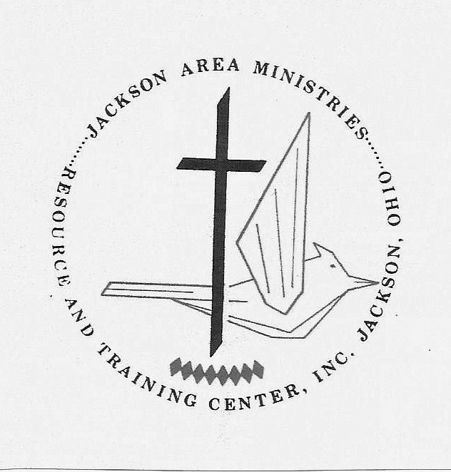

P.O. BOX 603
JACKSON, OHIO 45640
Email: jamjar@midohio.twcbc.com
Web page: www.jamumc.org
740-286-1320
1-888-237-3141

Updated December 2018
Group Registration Fee $500.00
Your date will not be reserved
until the group registration fee is paid.
Material Fee…. $90.00 per person
Half due April 15. Remainder due week of camp.

Work campers typically arrive on Saturday evening and worship with the host church on Sunday. Leaders will visit the work site on Sunday afternoon. All work camp teams are asked to provide 4 full days of work.

WORK CAMP APPLICATION

CHURCH ________________________________________

ADDRESS____________________________________

__________________________________ZIP___________

PHONE__________________________________________

CONTACT PERSON ________________________
ADDRESS_______________________________________

_________________________________ZIP____________

PHONE__________________________________________

EMAIL ADDRESS______________________________________

DATES DESIRED:
1._____________ 2. _______________ 3. ______________

GROUP (Number)
7th – 8th Grades _________________
9th – 12th Grades ________________
Adults __________________________
Total in Group _____________________

LISTING OF SKILLS…
(check the categories that apply)

Carpentry Youth________ Adult_______
Home Repairs Youth________ Adult_______
Roofing Youth________ Adult_______
Painting Youth________ Adult_______
Bible School Youth________ Adult_______
____ Our church has participated in a Work Camp

List any identifiable skills that individuals and/or your group possess ______________________________________
_______________________________________________

ADDITIONAL REQUIREMENTS

Your church must have a Safe Sanctuaries* policy (child protection guidelines) and the adults in your group must be certified under that policy. Prior to work camp, you should designate at least one adult from your group to monitor the guidelines adopted by your church.

*for more information on this policy go to westohioumc.org/conference/safe-sanctuaries
[Note: your guidelines may be known as “safe church”]

RETURN APPLICATION AND FEES TO:
JACKSON AREA MINISTRIES
P.O. BOX 603
JACKSON, OHIO 45640

Or email to: jamjar@midohio.twcbc.com
Or fax to: 740-288-4308

