NES Health & Bioenergetics

When it comes to health, bioenergetics goes beyond chemistry to look more deeply into root causes by exploring energy and the energy fields that control it. This gives us insights into where the body needs support so we can work to correct it rather than just suppressing symptoms. This also lets us explore the realm where consciousness interacts with physical reality, giving us insights into how stress and emotions affect our health.

With the NES Health software, we look at these details of the body’s true control system:

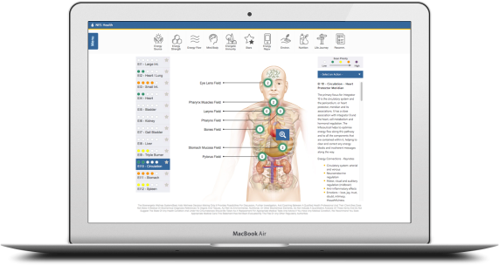
- How it’s interacting with its environment
- How well powered it is
- How well communication is taking place for both everyday health and for healing processes
- How it’s impacted by stress and traumas, and where this may be affecting the body
- How well it’s recognizing and responding to nutrients and toxins

While this is not a medical assessment, most people are astonished by its accuracy and insights. Results focus not on disease, but on where improvements can be made, and this is achieved through lifestyle choices as well as bioenergetic technology and remedies.

Interested to know more? Create a FREE account and get free access to:

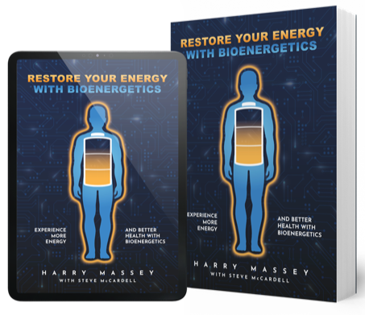
- Bioenergetic films, articles, podcasts, recipes, and more.
- A groundbreaking ebook on health.
- Relaxing music tracks imprinted with resonance wellness technology.
- A shop with exclusive bioenergetic products.

And if you’d ever like to take the next step with a complete wellness scan, having an account makes that easy to do, and I’ll be happy to assist.

Ready to explore bioenergetics?

Create your FREE account here: LINK

Name * Telephone * Email
www.yourwebsite.com

